**NORTHAMPTON COUNTY SCHOOLS**

***“Changing the Lives of Children”***

**Middle and Secondary Curriculum Guide**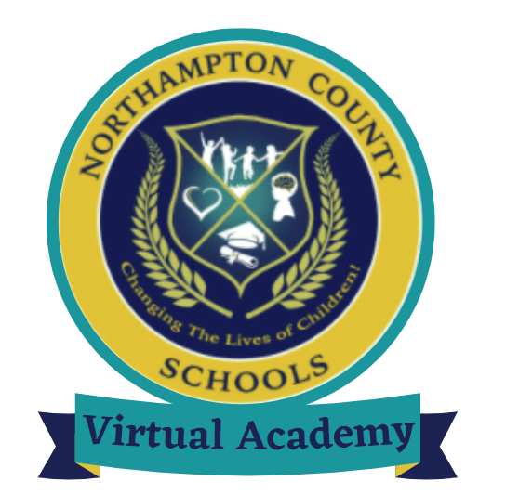

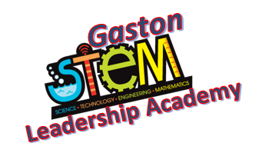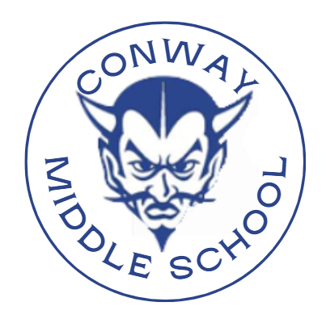

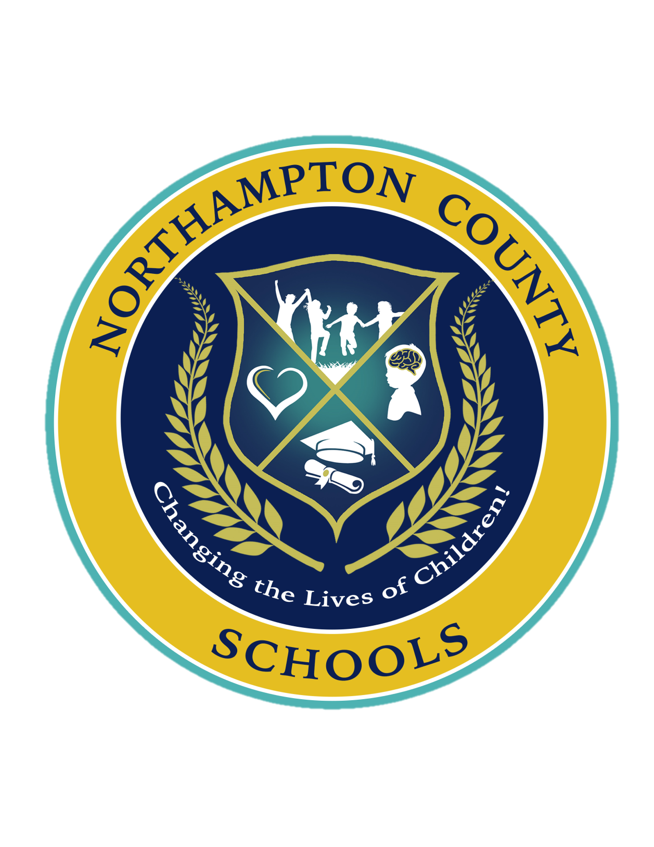

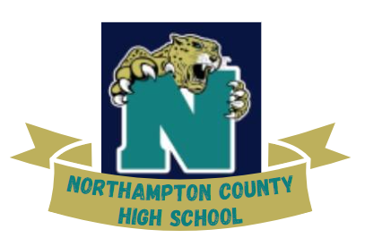

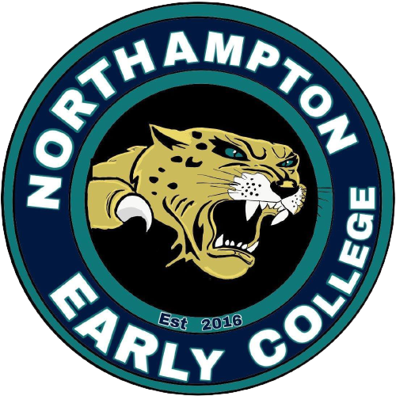

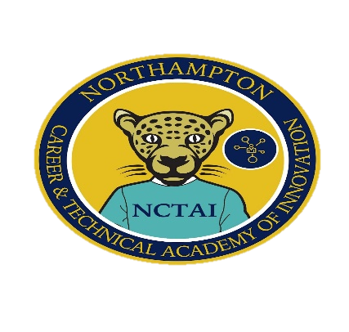

____________________________________________________________________

**2023-2024**

# To Northampton County Students & Parents

The purpose of the Middle and High School Curriculum Guide is to give you information about graduation requirements, course listings, and other related matters that will help you make decisions about the course selections for each year. The purpose of this guide is to help you prepare for your post-secondary goals for higher education, military and/or work. It is very important that you discuss these decisions before making final selections during your registration process with your School Counselors.

**NORTHAMPTON COUNTY SCHOOLS**

In compliance with Federal Law, Northampton County Schools administers programs , employment activities, and admissions without discrimination against a person on the basis of gender, race, color, religion, national origin, age, or disability. The following persons have been designated to handle inquiries regarding the nondiscrimination policies.

**Dr. Shirley Vinson,** Section 504 and Title IX

**Mark Long,** Title II

Each may be contacted at :

**Northampton County Schools**

701. North Church Street

Jackson, NC 27845

**ANNUAL NOTICE**

Northampton County Schools offers a variety of Career and Technical Education (CTE) programs to all students at the middle and high school levels. The CTE program areas include the following: Family and Consumer Science Education, Career Development, Trade and Industrial Services Education, HVAC, Industrial Systems, Cosmetology, EMT, and Nurse Aide.

**NON-DISCRIMINATION STATEMENT**

Career and Technical Education (CTE) is an integral part of Northampton County Schools. In compliance with Federal Laws, Northampton County Schools does not discriminate on the basis of race, color, religion, national origin, age, or disability in any services offered in its Career and Technical Education program. To ensure all students have access to CTE programs and are successful, support services are provided by the CTE Career Development Coordinator /Special Populations Coordinator as well as the Northampton County Director of Student Services.

# TABLE OF CONTENTS

|  |  |
| --- | --- |
| **Northampton County Schools Middle and High School Listing** | 5 |
| **Middle School Information** | 6 |
| Middle School Grading System | 7 |
| Middle School Courses and Electives | 8 |
| Scheduling High School Courses for Middle School Students | 9 |
| Middle School Assessments | 10 |
| High School Courses for Middle School Students FACTS | 11 |
| Math Course Sequence for Acceleration | 12 |
| Middle School Students with Special Needs | 13 |
| Section I: Core Program Descriptions | 14 |
| Sixth Grade Core Program | 14-16 |
| Seventh Grade Core Program | 17-19 |
| Eighth Grade Core Program | 20-22 |
| Arts Education Electives | 22 |
| Career and Technical Education Middle School Electives | 23 |
| Middle School Athletics | 24 |
| Section II: Planning for Your Future | 25 |
| Looking Ahead to the High School Program | 25-26 |
| **High School Information** | 27-28 |
| NCS Graduation Requirements | 29 |
| Diploma and Promotion Requirements | 30 |
| Early Graduation | 31 |
| Early Release | 31 |
| Registration Information | 32 |
| Enrollment Requirements | 32 |
| Class Load Requirements and Early Release | 32 |
| Planning for the Future | 32 |
| Registration Process for the 4 x 4 Block Schedule | 33 |
| High School Assessments | 34 |
| College Admission Requirements for UNC Campuses | 35 |
| Schools in the University of North Carolina System | 36 |
| NC Academic Scholars Program Requirements | 37 |
| Honors and Advanced Placement (AP) Course Criteria | 38-39 |
| North Carolina Standardized Transcript | 39 |
| 10 Point Grading Scale | 39 |
| Academic Honors | 40 |
| Class Rank | 40 |
| Latin Honors | 40-41 |
| Scholastic Requirements for High School Athletes | 41 |
| The NC Driver’s License Law | 41 |
| **Career and College Promise Opportunities** | 42 |
| **RISE, CCRG, and CCP Alignment Implementation Timeline** | 42 |
| Cooperative Innovative High School (CIHS) Course Eligibility Policy | 43 |
| Program Eligibility Benchmarks on Approved Diagnostic Assessment | 44 |
| Career and Technical Education Pathways Available at HCC | 45-46 |
| Career and Technical Education Pathways Available at R-CCC | 47 |
| **NCS CCP: CTE available from R-CCC with placement at NORTHAMPTON CAREER & TECHNICAL ACADEMY OF INNOVATION** | 48-51 |
| **High School Course Descriptions** | 52 |
| English | 53-54 |
| World Language | 54-55 |
| Mathematics | 55-58 |
| Science | 58-60 |
| Social Studies | 60-63 |
| Fine Arts | 63-64 |
| Health & Physical Education | 64-65 |
| ARMY JROTC | 65-67 |
| Career and Technical Education | 68-77 |
| Special Interest Topics | 78 |
| **Exceptional Children OCS Course Descriptions** | 79-84 |
| **North Carolina Extended Content Standards** | 85 |
| **NCDPI Course Guidance Materials for Social Studies and Mathematics** | 86-92 |
| **High School Graduation Checklist** | 93-94 |
| **Halifax Community College Graduation Checklist** | 95-97 |

**NORTHAMPTON COUNTY SCHOOLS MIDDLE SCHOOLS AND HIGH SCHOOLS**

|  |  |
| --- | --- |
| **Middle Schools** | **High Schools** |
| **Conway Middle School (4-8)**  400 E Main St.  Conway, NC 27820  **Principal, Darren Parker**  **Assistant Principal, Marilyn Lawrence**  **Counselor, Tamiaya Allen**  Phone: 252-585-0312 | **Northampton County High School (9-12)**  152 Hurricane Drive  Gaston, NC 27832  **Principal, Larry Ferebee**  **Assistant Principal, Sharita Wade**  **Counselor, Viola Gilbert**  Phone: 252-537-1910 |
| **Northampton County Career and Technical Academy of Innovation (NCTAI)**  750 Nchs East Rd  Conway, NC 27820  **Director, Dr. Amy L. Draper**  **Counselor, Viola Gilbert**  Phone: 252-534-1371 |
| **Gaston STEM Leadership Academy (Pk-8)**  400 Broughton Street  Gaston, NC 27832  **Principal, Jagtar Singh**  **Assistant Principal, Benedict Fagbeyiro**  **Counselor: Shaun Engleby**  **Counselor: Cheri Johnson**  Phone: 252-537-2520 | **Northampton County Early College (9-13)**  100 College Drive  Weldon, NC 27890  **Principal, Monica M. Edmonds**  **Counselor, Jessica Stallings**  Phone: 252-536-5480 |
| **Northampton County Virtual Academy (K-12)**  701 N. Church Street  Jackson, NC 27845  **Principal, Monica M. Edmonds**  Phone: 252-536-5480 | |

**NORTHAMPTON COUNTY SCHOOLS**

***“Changing the Lives of Children”***



**Middle School Information**

**Conway Middle School(4-8)**

**Gaston STEM Leadership Academy(K-8)**

**Northampton County Virtual Academy (K-8)**

**Middle School Grading System**

**Letter Grades** – Note: The grading scale below represents changes to Policy 3420-R in August 2018. Students earn letter grades of A, B, C, D, or F on their report cards. They may also be assigned a grade of "I" for "Incomplete" if, because of an emergency, they do not complete work by the end of the grading period. The "Incomplete" becomes an "F" if work is not finished by an assigned time. Letter grades have the following numerical values:

A = 90-100

B = 80-89

C = 70-79

D = 60-69

F = less than 60

Performance on the End-of-Course test will count as **20%** of the final grade for students enrolled in middle school NC Math 1 or any other high school credit course that requires an EOC. Students enrolled in other high school credit courses will have an exam that counts **20%** of the overall grade. Depending on the course, this may be a state, district, or teacher exam.

**Report Cards -**Report cards are issued within a week following the end of each grading period. At the midpoint of the first and third reporting periods, all students receive interim reports to take home to parents. At the midpoint of the second and fourth reporting periods, students who are failing or whose grades have fallen a letter grade will again receive interim reports.

**Promotion Requirements** Northampton County School (NCS) policy (3420-R) requires grade-level proficiency in reading and mathematics in order to be promoted to the next grade level in grades 6-8. To be promoted, students must meet test proficiency standards and receive a passing grade (D or better) in:

• Language Arts,

• Mathematics,

• Social Studies or Science,

• Half of all remaining courses taken.

The superintendent shall develop (1) proposed promotion standards and (2) a process to be used in determining a student’s readiness to progress to the next level of study and shall submit the standards and process to the board for approval. The standards will be based, in part, upon proficiency in reading. The standards and process must provide multiple criteria for assessing a student’s readiness to progress to the next level of study, such as standardized test scores, formative and diagnostic assessments, grades, a portfolio or anthology of the student’s work, and, when appropriate, accepted standards for assessing developmental growth.

Principals shall ensure that the promotion standards are used by teachers and school administrators in assessing each student’s readiness to progress to the next level of study. Principals have the authority to promote or retain students based upon the standards approved by the board and any applicable standards set by the State Board of Education.

In addition to academic performance requirements, students must meet the requirements of the NCS attendance policy 4400. Failure to meet the requirements of the attendance policy may result in failure of a class and grade retention.

**Middle School Courses and Electives**

|  |  |  |  |  |
| --- | --- | --- | --- | --- |
| **Sixth Grade** | | | | |
| English/Language Arts (10562Y0) | Math 6 (20062Y0) | Science (30062Y0) | Social Studies (40062Y0) | Healthful Living (60462Y0) |
| **Seventh Grade** | | | | |
| English/Language Arts (10572Y0) | Math 7 (20072Y0) | Science (30072Y0) | Social Studies (40072Y0) | Healthful Living (60472Y0) |
| **Eighth Grade** | | | | |
| English/Language Arts (10582Y0) | Math 8 (20082Y0) | Science (30082Y0) | Social Studies (40082Y0) | Healthful Living (60482Y0) |
| **High School Courses for Eighth Graders** | | | | |
| English I(10212Y0)  NC Math 1 (21092Y0)  Earth/Environmental (35012Y0)  Civic Literacy(43182Y0) | | | | |
| **Career and Technical Education Electives** | | | | |
| **Conway Middle School** | |  | **Gaston STEM Leadership Academy** | |
| (6th)  Keyboarding/Word Processing  (CY012Y0) | | (6th)  Exploring Personal Characteristics & Careers  (EY102Y0) | |
| (7th)  Digital Literacy  (CY042Y0) | | (7th-8th)  Exploring Careers and Employment  (EY112Y0)  (8th)  (Paxton-Patterson Lab) | |
| (8th)  Office Productivity Applications  (CY032Y0)  (Paxton-Patterson Lab) | |

**Scheduling High School Courses for Middle School Students**

The Middle School Program builds the foundation for high school success, and planning your educational program is one of the most important steps to a successful high school experience. The information below will help you plan for high school and beyond.

As outlined in SBE Policy GCS-M-001, students have the opportunity to earn high school credit while in middle school. NCS has determined that the following courses will be available to middle school students beginning with the 2014-15 school year.

Please note that teacher-led courses taught for high school credit at the middle school level may require specific teacher certification.

|  |  |
| --- | --- |
| **Course Name** | **Course Code if offered on NCVPS** |
| **English/Language Arts** | |
| English I | 10212Y0VPS |
| **Mathematics** | |
| NC Math 1 | 21092Y0VPS |
| **Science**  **The course must be taken in addition to 6-8 Science courses.** | |
| Earth/Environmental Science | 35012Y0VPS |
| **Social Studies**  **These courses must be taken in addition to 6-8 Social Studies courses.** | |
| Civics Literacy | 43182Y0VPS |

If schools are unable to accommodate the scheduling of the courses as teacher-led courses, then the course may be taken online via NCVPS. (See chart for details).  **Math courses can be substituted for grade level math courses. All other courses will be taken in addition to, not in place of, the standard middle school curriculum (i.e. Earth Science does not replace 8th grade science).**

Course codes for high school courses are available for middle school students as noted above in the chart. **These are the ONLY face-to face available for middle school students to take and receive eligible high school credits.**

**\*\* Teachers must be certified to teach the high school level courses assigned.**

## 

# Middle School Assessments

## At the middle school level, students will participate in a number of required state tests. Please see the chart below.

## NC End-of-Grade Reading Test (EOG): 3rd-8th grades Purpose: Assess mastery of grades 3-8 reading based on N.C. Standard Course of Study Standards

## NC End-of-Grade Math Test (EOG): 3rd-8th grades Purpose: Assess mastery of grades 3-8 math based on N.C. Standard Course of Study Standards

## NC End-of-Grade Science Test (EOG): 8th grade only Purpose: Assess mastery of grade 6-8 science based on Essential Standards

## NC End-of-Course Math I Test (EOC): 8th grade only Purpose: Assess mastery of Math I N.C. Standard Course of Study Standards

* **Teacher Made Assessments**

## Purpose: Assess mastery of 6-8 grade social studies based on the Essential Standards and other content areas

## At the middle school level students will participate in a number of required state tests including:

|  |  |  |  |
| --- | --- | --- | --- |
| **Name of**  **Assessment** | **Grade Level** | **When**  **Administered** | **Purpose** |
| NC End-Of  Grade Tests  (EOG) | 3rd - 8th | See Testing Calendars | Assesses mastery of grades 3-8 reading and  mathematics based on State Standards*.* Students must also take the Science EOG at the end of Grade 8. The EOG is administered in the last 10 days of the school year. |
| NC End-Of  Course Tests (EOC) | 7th - 12th | See Testing Calendars | Assesses mastery of grades 7-12 courses in  select content areas based on the State Standards. The EOC is administered within the last 5 days of semester long courses and the last 10 days of year-long courses. |

**Middle school students also participate in formative and benchmark assessments. These are much shorter assessments that help teachers and school leaders to guide instruction based on how students are progressing with the concepts in the class.** These assessments will not count as grades at any middle school in the district. However, schools may make assignments for remediation and enrichment based on the outcomes of these assessments that can count as a grade in the course.

## High School Courses for Middle School Students FACTS

## Frequently Asked Questions

**1. Will the grade earned in high school courses taken in middle school appear on the high school transcript**?

Yes. The grade will be listed on the transcript under Grades 6, 7, or 8 with one unit of credit.

**2. Will the grade earned be included in the student's high school grade point average (GPA)?**

No, Only courses taken during the high school years will be included in the student’s grade point average.

**3. Can a student repeat a course for credit at the high school level?**

Students are permitted to repeat a course to build a stronger foundation for future learning. Students wishing to do this should make a written request to their principal or principal’s designee. When students choose this option, please note:

* Students will receive a numerical grade and both grades will appear on the high school transcript.
* Only grades earned in high school are included in a student’s high school GPA.
* Students retaking a course that they previously passed to build a stronger foundation will not receive elective credit for the second attempt with the course.
* Students repeating a course for credit will take any associated End-of-Course (EOC) assessment. Those students who have already scored at Level 3, 4, or 5 on the associated EOC assessment may elect either to retake the EOC or use the previous passing EOC score as **20%** of their final grade. If the student retakes the EOC, the higher of the two scores will be used in the calculation of the final grade.

**Mathematics Courses for High School Credits**

**4**. **Is there a placement exam?**

No. Students who successfully complete mathematics courses may be placed in the next level of mathematics based on middle school math placement guidelines.

**5. Are students required to take a standard exam for the course?**

Students taking NC Math 1 must take the NC Math 1 End of Course Test, which counts as 20% of their final grade. Students taking other high school math courses will take a teacher-made exam that counts as 20% of their final grade.

**Middle School Math Course Sequence for Acceleration**

|  |  |  |  |  |
| --- | --- | --- | --- | --- |
| **Grade 6** |  | **Grade 7** |  | **Grade 8** |
| **Math 6** | **Math 7** | **Math 8** |
| **Accelerated Math 6/7** | **Accelerated Math 7/8** | **Math 8 or NC Math I** |
| **Accelerated Math 7/8** | **NC Math 1\*** |  |

**\*Students in the Highly Academically Gifted or International Baccalaureate programs may qualify for a sequence of Accelerated Math 7/8 in sixth grade, NC Math 1 in seventh grade, and NC Math 2 in eighth grade.**

**Accelerated Math 6/7 (20092Y0)**

This accelerated course focuses on connecting unit ratios to whole number multiplication, division, and problem solving; division of fractions and extending the notion of number to the system of rational numbers; understanding of operations with rational numbers; using expressions and equations; solving problems involving informal geometric constructions and working with 2- and 3- dimensional shapes; statistical thinking; and drawing inferences about populations based on samples. Students solve relevant problems that require inquiry, collaboration, and communicating about their learning.

**Accelerated Math 7/8 (20122Y0)**

This accelerated course focuses on understanding and applying proportional relationships; formulating and reasoning about expressions and equations; solving problems involving scale drawings and working with 2- and 3-dimensional shapes; analyzing 2- and 3-dimensional space and figures; drawing inferences about populations based on samples; and the Pythagorean Theorem. Students solve relevant problems that require inquiry, collaboration, and communicating about their learning.

Seventh grade students who are taking NC Math 1 are required by the state to take both the NC Math 1 End-of-Course (EOC) test as well as the seventh grade EOG in math. State policy requires EOCs count 20 percent of a student’s final grade. In these situations, the NC Math 1 EOC will be used as 20 percent of the final grade, and the Grade 7 Math EOG will be used as a test grade in the fourth quarter, as long as it would not lower the student’s grade.

**Middle School Students with Special Needs**

**Academically or Intellectually Gifted (AIG)**

At the middle school level, screening and placement for the Academically or Intellectually Gifted program occur as appropriate and on an individual basis. Teachers, administrators, other school staff, students, and/or parents/guardians may nominate students for the AIG Program at any time, though there is one testing window per semester to ensure all students have the same number of instructional days prior to being assessed. Students may be identified for services in language arts, mathematics, or in both areas.

Students in the Northampton County Schools are identified using a state-approved model that includes not only aptitude and achievement test scores, but also other indicators of giftedness such as student portfolios, classroom behaviors, performance, interest, and motivation. Students who meet the criteria for AIG services are identified accordingly. Students who qualify for the AIG program are served through differentiation strategies designed to provide challenges and appropriate instruction in language arts classes and/or in mathematics courses.

**Special Education Services**

All Northampton County Middle Schools provide services for students with disabilities who meet state criteria for Special Education Services. Students who are suspected of having a disability are typically referred by their parents or by school personnel. The IEP Team will review data and information to determine if an evaluation for special education consideration is necessary. Following the evaluation, if one was completed, an IEP team, to include the parents, determines whether the student is eligible. Every eligible student has an Individualized Educational Program (IEP), which identifies the student’s strengths and needs and sets annual goals based on the identified needs. The IEP also reflects accommodations/modifications and specially designed instruction in the least restrictive placement in order for the student to make progress toward their annual goals and toward the general curriculum.

**Section I: Core Program Descriptions**

**Sixth Grade Core Program**

Sixth grade students study language arts, mathematics, science, social studies, and healthful living. Each middle school offers a program of electives selected from the courses described in Section III of this guide.

**English/Language Arts (10562Y0)**

Following the NC State Standards for English Language Arts, sixth graders develop skills in reading, writing, speaking, and listening, and language acquisition through experience with print and digital resources. Students read a wide range of text, varying in levels of sophistication and purpose. Through print and non-print text, they develop comprehension strategies, vocabulary, as well as high order thinking skills. Students read a variety of fiction, drama, poetry, and informational text such as memoirs, articles, and essays. During each module of study, students apply skills such as citing evidence, determining themes, and analyzing how parts of the text affect the whole.

Students learn about the writing-reading connection by drawing upon and writing about evidence from literary and informational texts. Writing skills, such as the ability to plan, revise, edit, and publish, develop as students practice specific writing types such as arguments, informative/explanatory texts, and narratives. Guided by rubrics, students write for a variety of purposes and audiences. Sixth graders also conduct short research projects drawing on and citing several sources appropriately.

Sixth graders practice communication and collaboration skills as they work together, express and listen to ideas, integrate information, and use media and visual displays to help communicate ideas. Students learn language conventions and vocabulary to help them understand and analyze words and phrases, relationships among words, and shades of meaning that affect the text they read, write, and hear. Students are encouraged to engage in daily independent reading to practice their skills and pursue their interests.

**Mathematics (20062YO)**

The North Carolina Standard Course of Study for 6-8 Mathematics consists of two types of standards – Standards for Mathematical Practice that span K-12 and the North Carolina Standard Course of Study for 6-8 Mathematics content specific to each course. The Standards for Mathematical Practice rest on important “processes and proficiencies” with longstanding importance in mathematics education. They describe the characteristics and habits of mind that all students who are mathematically proficient should be able to exhibit. The eight Standards for Mathematical Practice are:

1. Make sense of problems and persevere in solving them.

2. Reason abstractly and quantitatively.

3. Construct viable arguments and critique the reasoning of others.

4. Model with mathematics.

5. Use appropriate tools strategically.

6. Attend to precision.

7. Look for and make use of structure.

8. Look for and express regularity in repeated reasoning.

The North Carolina Standard Course of Study for 6-8 Mathematics content is organized under domains: *The Number System, Ratios and Proportional Relationships, Functions, Expressions and Equations, Geometry, and Statistics and Probability.*

**Math 6 (20062Y0**)

The foci of Math 6 are outlined below by domain.

* ***Ratios and Proportional Relationships:*** Understand ratio concepts and use ratio reasoning to solve problems.
* ***The Number System***: Apply and extend previous understandings of multiplication and division to divide fractions by fractions; compute fluently with multi-digit numbers and find common factors and multiples; apply and extend previous understandings of numbers to the system of rational numbers.
* ***Expressions and Equations:*** Apply and extend previous understandings of arithmetic to algebraic expressions; reason about and solve one-variable equations; reason about one variable inequality; represent and analyze quantitative relationships between dependent and independent variables.
* ***Geometry:*** Solve real-world and mathematical problems involving area, surface area, and volume
* ***Statistics and Probability:*** Develop understanding of statistical variability; summarize and describe distributions.

**Science** (**30062Y0**)

Traditional laboratory experiences provide opportunities to demonstrate how science is constant, historic, probabilistic, and replicable. Although there are no fixed steps that all scientists follow, scientific investigations usually involve collections of relevant evidence, the use of logical reasoning, the application of imagination to devise hypotheses, and explanations to make sense of collected evidence. Student engagement in scientific investigation provides background for understanding the nature of scientific inquiry. In addition, the science process skills necessary for inquiry are acquired through active experience. The process skills support development of reasoning and problem-solving ability and are the core of scientific methodologies.

By the end of this course, the students will be able to:

* Understand the earth/moon/sun system, and the properties, structures, and predictable motions of celestial bodies in the Universe.
* Understand the structure of Earth and how interactions of constructive and destructive forces have resulted in changes in the surface of Earth over time and the effects of the lithosphere on humans.
* Understand the structures, processes and behaviors of plants that enable them to survive and reproduce.
* Understand the flow of energy through ecosystems and the responses of populations to the biotic and abiotic factors in their environment.
* Understand the properties of waves and the wavelike property of energy in earthquakes, light and sound waves.
* Understand the structure, classifications, and physical properties of matter.
* Understand characteristics of energy transfer and interactions of matter and energy.

**Social Studies** (**40062Y0**)

Students in sixth grade will continue to expand the knowledge, skills, and understandings acquired in the fourth and fifth grade studies of North Carolina and the United States by connecting those studies to their first formal look at a study of the world. Sixth graders will focus heavily on the discipline of geography by using the themes of location, place, movement, human-environment interaction, and region to understand the emergence, expansion, and decline of civilizations and societies from the beginning of human existence to the Age of Exploration. Students will take a systematic look at the history and culture of various world regions including the development of economic, political, and social systems through the lens of change and continuity. As students examine the various factors that shaped the development of civilizations, societies, and regions in the ancient world, they will examine both similarities and differences among these areas. A conscious effort will be made to integrate various civilizations, societies, and regions from every continent (Africa, Asia, Europe, and the Americas). During this study, students will learn to recognize and interpret the “lessons of history;” those transferable understandings that are supported throughout time by recurring themes and issues.

**Healthful Living** (**60462Y0**)

Healthful Living is required for all 6th grade students and includes health education and physical education. These two courses complement each other as students learn how to be healthy and physically active for a lifetime. Because our health and physical fitness needs are so different from a generation ago, the nature of healthful living is changing. Poor health choices (i.e., use of alcohol and other drugs, poor nutrition, and physical inactivity) now account for more than 50% of the preventable deaths in the United States.

Through a quality healthful living education program, students will learn the importance of health and physical activity and develop skills to achieve and maintain a healthy lifestyle creating a heightened quality of life. Students will learn how to apply the concepts of proper exercise in their daily lives, discover ways to handle stress, avoid harmful and illegal drugs, learn about the relationship between nutrition and weight management, develop healthy interpersonal relationships (including conflict resolution skills), develop teamwork and character-building skills, and learn how to achieve positive health and fitness goals.

In sixth grade, students will learn a variety of communication techniques that will allow them to employ critical thinking skills to make positive health decisions. Students will appraise their own health and fitness status, understand sound nutrition principles, and develop sensible exercise practices. This knowledge will be applied as they demonstrate the ability to set, pursue and achieve personal health and fitness goals. Students will engage in physical activities that provide opportunities for rhythmic/dance movement, lead-up games enhancing basic sport skills, offensive and defensive game strategies, game rules/etiquette, problem solving, fair play, and sportsmanship.

Because of the nature of health education, discussion may include sensitive topics. By contacting the school principal, parents may request in writing that their child be excluded from certain health topics owing to personal/religious beliefs.

**Seventh Grade Core Program**

Seventh grade students continue their studies in language arts, mathematics, science, social studies, and healthful living.

**English/Language Arts** (**10572Y0**)

Following the NC State Standards for English Language Arts, seventh graders develop skills in reading, writing, speaking, and listening, and language through experience with print and digital resources. Students read a wide range of text, varying in levels of sophistication and purpose. Through print and non-print text, students increase their comprehension strategies, vocabulary, as well as high order thinking skills. They read a balance of short and long fiction, drama, poetry, and informational text such as memoirs, articles, and essays and apply skills such as citing textual evidence, analyzing points of view and presentation, and examining how parts of the text affect the whole. Experience with a variety of text types and text complexity helps students develop a knowledge

based essential for recognizing and understanding allusions.

Students learn about the writing-reading connection by drawing upon and writing about evidence from literary and informational texts. Writing skills, such as the ability to plan, revise, edit, and publish, develop as students practice skills of specific writing types such as arguments, informative/explanatory texts, and narratives. Guided by rubrics, students write for a variety of purposes and audiences. Seventh graders also conduct short research projects drawing on and citing several sources appropriately.

Seventh graders hone skills of flexible communication and collaboration as they learn to work together, express and listen carefully to ideas, integrate information, and use media and visual displays to help communicate ideas. Students learn language conventions and vocabulary to help them understand and analyze words and phrases, relationships among words, and nuances that affect the text they read, write, and hear. Students are encouraged to engage in daily independent reading to practice their skills and pursue their interests.

**Mathematics (2007AY0)**

The North Carolina Standard Course of Study for 6-8 Mathematics consists of two types of standards – Standards for Mathematical Practice that span K-12 and the North Carolina Standard Course of Study for 6-8 Mathematics content specific to each course.

The Standards for Mathematical Practice rest on important “processes and proficiencies” with longstanding importance in mathematics education. They describe the characteristics and habits of mind that all students who are mathematically proficient should be able to exhibit. The eight Standards for Mathematical Practice are:

1. Make sense of problems and persevere in solving them.

2. Reason abstractly and quantitatively.

3. Construct viable arguments and critique the reasoning of others.

4. Model with mathematics.

5. Use appropriate tools strategically.

6. Attend to precision.

7. Look for and make use of structure.

8. Look for and express regularity in repeated reasoning.

The North Carolina Standard Course of Study for 6-8 Mathematics content is organized under domains: *The Number System, Ratios and Proportional Relationships, Functions, Expressions and Equations, Geometry, and Statistics and Probability.*

**Math 7** (**20072Y0**)

The foci of Math 7 are outlined below by domain.

* ***Ratios and Proportional Relationships:*** Analyze proportional relationships and use them to solve real world and mathematical problems.
* ***The Number System:*** Apply and extend previous understandings of operations with fractions to add, subtract, multiply, and divide rational numbers.
* ***Expressions and Equations:*** Use properties of operations to generate equivalent expressions; solve real-world and mathematical problems using numerical and algebraic expressions, equations, and inequalities
* ***Geometry:*** Draw, construct and describe geometrical figures and describe the relationships between them; solve real-world and mathematical problems involving angle measure, area, surface area, and volume.
* ***Statistics and Probability:*** Use random sampling to draw inferences about a population; make informal inferences to compare two populations; investigate chance processes and develop, use, and evaluate probability models.

**Science** (**30072Y0**)

Traditional laboratory experiences provide opportunities to demonstrate how science is constant, historic, probabilistic, and replicable. Although there are no fixed steps that all scientists follow, scientific investigations usually involve collections of relevant evidence, the use of logical reasoning, the application of imagination to devise hypotheses, and explanations to make sense of collected evidence. Student engagement in scientific investigation provides background for understanding the nature of scientific inquiry. In addition, the science process skills necessary for inquiry are acquired through active experience. The process skills support development of reasoning and problem-solving ability and are the core of scientific methodologies.

By the end of this course, the students will be able to:

* Understand how the cycling of matter (water and gases) in and out of the atmosphere relates to Earth’s atmosphere, weather and climate and the effects of the atmosphere on humans
* Understand the processes, structures and functions of living organisms that enable them to survive, reproduce and carry out the basic functions of life.
* Understand the relationship of the mechanisms of cellular reproduction, patterns of inheritance and external factors to potential variation among offspring. Understand motion, the effects of forces on motion and the graphical representations of motion. • Understand forms of energy, energy transfer and transformation, and conservation in mechanical systems.

**Social Studies** (**40072Y0**)

Students in seventh grade will continue to expand upon the knowledge, skills and understanding acquired in the sixth-grade examination of early civilizations. Seventh graders study the world from the Age of Exploration to contemporary times in order to understand the implications of increased global interactions. The focus will remain on the discipline of geography by using the themes of location, place, movement, human-environmental interaction, and region to understand modern societies and regions. This course will guide students through patterns of change and continuity with a focus on conflict and cooperation, economic development, population shifts, political thought and organization, cultural values and beliefs and the impact of the environment over time. Through an investigation of the various factors that shaped the development of societies and regions in the modern world and global interactions, students will examine both similarities and differences. A conscious effort will be made to include an integrated study of various societies and regions from every continent (Africa, Asia, Europe, the Americas, and Australia).

**Healthful Living** (**60472Y0**)

Healthful Living is required for all 7th grade students and includes health education and physical education. These two courses complement each other as students learn how to be healthy and physically active for a lifetime. Because our health and physical fitness needs are so different from a generation ago, the nature of healthful living is changing. Poor health choices (i.e., use of alcohol and other drugs, poor nutrition, and physical inactivity) now account for more than 50% of the preventable deaths in the United States.

Through a quality healthful living education program, students will learn the importance of health and physical activity and develop skills to achieve and maintain a healthy lifestyle. Students will learn how to apply the concepts of proper exercise in their daily lives, discover ways to handle stress, avoid harmful and illegal drugs, learn about the relationship between nutrition and weight management, develop healthy interpersonal relationships (including conflict resolution skills), develop teamwork and character-building skills, and learn how to achieve positive health and fitness goals.

In seventh grade, students will appraise their own health status, apply communication, and stress management skills to prevent serious health risks, employ a variety of injury prevention techniques, understand the dietary guidelines, learn about the benefits of abstinence until marriage and the risks of premarital sexual intercourse, comprehend negative media messages, and demonstrate refusal skills related to peer pressure. Students will understand the risks associated with the use of alcohol and other drugs. In addition, students will learn how to encourage others not to engage in risky behaviors. Students will establish personal fitness goals and participate in social dance, small-sided games, and demonstrate advanced movement/skill sequences. Students will display appreciation toward the varying skill levels of teammates while enjoying the many benefits of physical activity.

Because of the nature of health education, discussion may include sensitive topics. By contacting the school principal, parents may request in writing that their child be excluded from certain health topics owing to personal/religious beliefs.

**Eighth Grade Core Program**

Eighth grade students continue their studies in language arts, mathematics, science, social studies, and healthful living. Courses in the core program are year-long. Elective courses may be offered in nine-week, semester, and/or year-long formats.

**English/Language Arts** (**10582Y0**)

Following the NC State Standards for English Language Arts, eighth graders develop skills in reading, writing, speaking, listening, and language through experience with print and digital resources. Students read a wide range of text, varying in levels of sophistication and purpose. Through print and non-print text, they further develop comprehension strategies, vocabulary, as well as high order thinking skills. They read a balance of short and long fiction, drama, and poetry with a focus on comparing how two or more literary elements create effects such as suspense or humor. Eighth graders approach informational text such as articles, arguments, and essays with the intent to cite textual evidence, analyze points of view and presentation, and evaluate accuracy and relevance of details. Experience with a variety of text types and text complexity helps students develop a knowledge-based essential for recognizing and understanding allusions.

Students learn about the writing-reading connection by drawing upon and writing about evidence from literary and informational texts. Writing skills, such as the ability to plan, revise, edit, and publish, develop as students practice skills of specific writing types such as arguments, informative/explanatory texts, and narratives. Guided by rubrics, students strategically write for a variety of purposes and audiences. Eighth graders also conduct short research projects drawing on and citing several sources appropriately.

Eighth graders hone skills of flexible communication and collaboration as they learn to work together, express and listen carefully to ideas, integrate information, and use media and visual displays to help communicate ideas. Students learn language conventions and vocabulary to help them understand and analyze words and phrases, relationships among words, and nuances that affect the text they read, write, and hear. Students are encouraged to engage in daily independent reading to practice their skills and pursue their interests.

**Mathematics (2008AY0)**

The North Carolina Standard Course of Study for 6-8 Mathematics consists of two types of standards – Standards for Mathematical Practice that span K-12 and the North Carolina Standard Course of Study for 6-8 Mathematics content specific to each course. The Standards for Mathematical Practice rest on important “processes and proficiencies” with longstanding importance in mathematics education. They describe the characteristics and habits of mind that all students who are mathematically proficient should be able to exhibit. The eight Standards for Mathematical Practice are:

1 Make sense of problems and persevere in solving them.

2. Reason abstractly and quantitatively.

3. Construct viable arguments and critique the reasoning of others.

4. Model with mathematics.

5. Use appropriate tools strategically.

6. Attend to precision.

7. Look for and make use of structure.

8. Look for and express regularity in repeated reasoning.

The North Carolina Standard Course of Study for 6-8 Mathematics content is organized under domains: *The Number System, Ratios and Proportional Relationships, Functions, Expressions and Equations, Geometry, and Statistics and Probability.*

**Math 8** (**20082Y0**)

The foci of Math 8 are outlined below by domain:

* ***The Number System***: Know that there are numbers that are not rational and approximate them by rational numbers.
* ***Expressions and Equations:*** Work with radicals and integer exponents; analyze and solve linear equations and inequalities; analyze and solve pairs of simultaneous linear equations.
* ***Geometry:*** Understand congruence and similarity using physical models, transparencies, or geometry software; analyze angle relationships; understand and apply the Pythagorean Theorem; solve real-world and mathematical problems involving volume of cylinders, cones, and spheres.
* ***Statistics and Probability:*** Investigate patterns of association in bivariate data.
* ***Functions:*** Define, evaluate, and compare functions; use functions to model relationships between quantities.

**NC Math 1 (for High School Credit)** (**21092Y0**)

This course deepens and extends understanding of linear relationships, in part by contrasting them with exponential and quadratic phenomena, and in part by applying linear models to data that exhibit a linear trend. In addition to studying bivariate data, students also summarize, represent, and interpret data on a single count or measurement variable. The geometry standards that appear in this course formalize and extend students’ geometric experiences to explore more complex geometric situations and deepen their explanations of geometric relationships, moving towards formal mathematical arguments. The Standards for Mathematical Practice apply throughout the course and, together with the content standards, require that students experience mathematics as a coherent, useful, and logical subject that makes use of their ability to make sense of problem situations. This course fulfills the North Carolina high school graduation requirement for NC Math 1. The final exam is the NC Math 1 End-of-Course test, and it will be averaged as **20%** of the overall grade for the course. ***Please note: Except in extraordinary circumstances as outlined by the state, students will not be able to withdraw from NC Math 1 after the 20th day of school (10th day on a semester block).***

**Social Studies** (**40082Y0**)

Historical study connects students to the enduring themes and issues of our past and equips them to meet the challenges they will face as citizens in a state, nation, and an interdependent world. Pursuant to the passage of House Bill 1032 *An Act Modifying the History and Geography Curricula in the Public Schools of North Carolina,* the new essential standards for eighth grade will integrate United States history with the study of North Carolina history. This integrated study helps students understand and appreciate the legacy of our democratic republic and to develop skills needed to engage responsibly and intelligently as North Carolinians. This course will serve as a stepping stone for more intensive study in high school. Students in eighth grade will continue to build on the fourth and fifth grade introductions to North Carolina and the United States by embarking on a more rigorous study of the historical foundations and democratic principles that continue to shape our state and nation. Students will begin with a review of the major ideas and events preceding the foundation of North Carolina and the United States. The main focus of the course will be the critical events, personalities, issues, and developments in the state and nation from the Revolutionary Era to contemporary times. Inherent in this study is an analysis of the relationship of geography, events and people to the political, economic, technological, and cultural developments that shaped our existence in North Carolina and the United States over time.

**Healthful Living** (**60482Y0**)

Healthful Living is required for all 8th grade students and includes health education and physical education. These two courses complement each other as students learn how to be healthy and physically active for a lifetime. Because our health and physical fitness needs are so different from a generation ago, the nature of healthful living is changing. Poor health choices (i.e., use of alcohol and other drugs, poor nutrition, and physical inactivity) now account for more than 50% of the preventable deaths in the United States.

Through a quality healthful living education program, students will learn the importance of health and physical activity and develop skills to achieve and maintain a healthy lifestyle. Students will learn how to apply the concepts of proper exercise in their daily lives, discover ways to handle stress, avoid harmful and illegal drugs, learn about the relationship between nutrition and weight management, develop healthy interpersonal relationships (including conflict resolution skills), develop teamwork and character-building skills, and learn how to achieve positive health and fitness goals.

In eighth grade, students will identify how media and peer pressure influence health behaviors, identify positive ways to manage stress, explain how to gain, reduce, or maintain weight in a healthy manner, demonstrate skills and strategies for remaining abstinent from sexual intercourse, and demonstrate good communication skills for healthy relationships. Students will demonstrate basic CPR skills, understand the special risks associated with alcohol and other drugs, understand the negative impact (emotional, social, and physical) of using harmful and illegal drugs, and assist others to seek help for risky behaviors. Students will explain the principles of cardiovascular and strength conditioning, develop a personal fitness program, establish personal fitness goals, and monitor their progress, participate in regular physical activity both in school and during non-school hours, display advanced sport movements through the engagement in dual, team, and lifetime sports. Students will work cooperatively to follow rules and exhibit safe practices while achieving individual and group fitness-related goals through fair play and sportsmanship.

CPR instruction is presented as part of the 8th grade Health curriculum. Beginning with the graduating class of 2015 (current 8th graders and beyond), successful completion of CPR instruction is a high school graduation requirement for all North Carolina students. Successful completion is defined in the Essential Standards Curriculum as “demonstrating basic CPR techniques and procedures on a mannequin and passing a Red Cross or American Heart Association approved test of CPR skills.” Students who successfully complete CPR in 8th grade are considered to have met the requirement.

Because of the nature of health education, discussion may include sensitive topics. By contacting the school principal, parents may request in writing that their child be excluded from certain health topics owing to personal/religious beliefs.

**Arts Education Electives**

*Elective offerings vary by school; therefore, each school prepares a registration sheet that lists the electives it will offer. The availability of electives depends on student interest, an appropriate facility, and staffing.*

**MUSIC**

**Beginning Band (year-long course)** (**52862Y0/52872Y0/52882Y0**)

Emphasis is on the acquisition of basic musical skills as students learn to play a brass, woodwind, or percussion instrument. Band classes prepare several concert compositions that are performed for an audience. Students should anticipate some after-school practices and evening performances.

**Career and Technology Education Middle School Electives**

**Digital Literacy (CY042Y0)**

This middle school course is composed of instructional modules designed to allow students to learn the touch method of keyboarding, digital literacy and computer knowledge, and basic word processing and document formatting skills. English language arts and mathematics are reinforced.

**Keyboarding and Basic Word Processing (CY012Y0)**

This course is composed of a series of instructional modules designed to provide project-based instruction in basic keying skills, computer concepts and software applications. The four modules covered are alpha keys, number/symbol keys, building speed and accuracy and basic business correspondence. Students also participate in Future Business Leaders of America (FBLA) competitive events, community service, and leadership activities. These activities provide students the opportunity to apply essential standards and workplace readiness skills through authentic experiences. Language arts is reinforced.

**Exploring Personal Character and Careers (EY102Y0)**

This course is composed of two instructional modules designed to provide project-based instruction in self-awareness, understanding the world of work and the career planning process. The two modules covered explore how career choices are influenced by interests, attitudes, values, personalities, learning styles, and skills. Students also participate in Future Business Leaders of America (FBLA) competitive events, community service, and leadership activities. These activities provide students the opportunity to apply essential standards and workplace readiness skills through authentic experiences. Language arts is reinforced.

**Exploring Careers and Employment (EY112Y0)**

This course is composed of two instructional modules designed to provide project-based instruction in self-awareness, understanding the world of work and the career planning process. The two modules covered explore the world of work, employment success and job search techniques. Students also participate in Future Business Leaders of America (FBLA) competitive events, community service, and leadership activities. These activities provide students the opportunity to apply essential standards and workplace readiness skills through authentic experiences. Language and mathematics are reinforced.

**Office Productivity Applications (CY032Y0)**

This course is composed of a series of instructional modules designed to provide project-based instruction in computer concepts and software applications. The three modules covered are spreadsheets – charts and advanced functions, database basics, and desktop publishing. Students also participate in Future Business Leaders of America (FBLA) competitive events, community service, and leadership activities. Language arts and mathematics are reinforced.

**Paxton Patterson Lab**

The ultimate career exploration to engage students in authentic problem-based learning experiences as they discover their interests and aptitudes. Whether you are looking to build a program with exposure to a broad range of Career Clusters, or define a more focused pathway, College & Career Ready Labs provide a model for success.

# 

# Middle School Athletics

* NCS is pleased to be able to offer a variety of athletics to help round out the middle school experience for both male and female students.
* Middle school students are automatically eligible for fall sports but must meet academic eligibility requirements for the second semester. For reasons of safety, district policy prohibits sixth graders from playing football. Listed below are the varsity sports offered.

|  |  |  |
| --- | --- | --- |
| **Fall** | **Winter** | **Spring** |
| Football(CMS & GSLA)  Volleyball - girls Cheerleading | Basketball - boys & girls  Cheerleading | Softball - girls  Baseball - boys  Track |

**Section II: Planning for Your Future**

**Looking Ahead to the High School Program**

The Middle School Program builds the foundation for high school success, and planning your educational program is one of the most important steps to a successful high school experience. The information below will help you plan for high school and beyond.

**Planning for High School**

High school students take rigorous courses that build the foundation for success in college, the military, or the workforce. The Future Ready Core Course of Study was established by the NC State Board of Education as the minimum units required for graduation. The following pages of this guide provide additional information for your high school planning, including the North Carolina Scholars recognition and University of North Carolina System Minimum Course Requirements for entrance into the 16 UNC System universities. Although you are not yet in high school, it is helpful to have an understanding of what is to come. In the spring of your eighth-grade year, you will be given the High School Program Planning Guide which outlines the entire high school program. At that time, you will also be guided by your eighth-grade teachers and school counselors in selecting courses for ninth grade.

**Exploring Careers**

Exploring your career interests will help you with high school planning. Consider taking a career interest inventory to help you focus on what you might want to consider for a career. Knowing more about your interests and skills will help you plan for your high school experience. You can take a free interest inventory at www.CFNC.org.

**Credit by Demonstrated Mastery**

Students in Northampton County Schools have the option to earn certain course credits toward graduation without taking the actual course. This statewide process, termed Credit by Demonstrated Mastery or CDM, includes required testing and portfolio components. Applications to participate are available from the school. General information for students and families may be viewed by accessing the Credit by Demonstrated Mastery webpage from our district website.

**FAQs CREDIT BY DEMONSTRATED MASTERY**

1. **What does CDM stand for?** Credit by Demonstrated Mastery

2. **Can my student earn credit towards graduation?** Yes, CDM is a two-phase process that allows students to receive credit for a course instead of traditional course enrollment and seat time.

3. **What courses are available through CDM?** Any course offered through NCHS except: Health and PE, any course that requires work based on learning or apprenticeship such as CTE Advanced Studies; or any course that requires field study. Students cannot be currently enrolled in the course. Students have to be taking the course for CDM for the first time.

4. **Who is eligible to go through the CDM process?** Any student enrolled at NCHS in grades 9-12.

5. **What does a student have to do if they wish to start the CDM process?** Students can contact their grade level counselor. The student will be given an application to complete Page 42 with their parent or guardian. Once the application is turned in, the student will begin the CDM phase I.

6. **When can my student start this process?** There are two opportunities for students to begin this process. There is a deadline in the fall and spring of each school year. Dates will be released at the beginning of the school year.

7. **What is Phase I?** Phase I is the assessment of foundational understanding. Students will be given a test. For state tested courses, students will take the NC Final or the EOC. For other courses such as Spanish I, students will take a local exam.

**North Carolina Virtual Public School**

Online course opportunities, including content electives and Advanced Placement classes, are available at no charge to the student through North Carolina Virtual Public School (NCVPS). The online course options may be reviewed by accessing ncvps.org and meeting with your counselor.

**North Carolina School of Science and Mathematics**

Students in Northampton County Schools may also participate in advanced math and science elective courses provided online at no charge through the "Interactive Videoconference" (IVC) program at NC School of Science and Mathematics (NCSSM). Example courses include Genetics, Multivariable Calculus, Ecocriticism, and Computational Science. Additional details about the available IVC courses may be reviewed by accessing NCSSM's Distance Learning program webpage.

**EdOptions**

EdOptions Academy is a fully accredited K through career online school that offers award-winning curriculum, state-certified teachers, instructional services, and accredited high school diplomas to schools and students who need flexible learning options.

**NORTHAMPTON COUNTY SCHOOLS**

***“Changing the Lives of Children”***



**High School Information**

Northampton County High School (9-12)

Northampton County Early College (9-13)

Northampton Virtual Academy (9-12)

# Northampton County High School

Northampton County High School is a traditional school, which provides students the opportunity for Career and Technical Education Pathways and Career and College and Promise (CCP). These opportunities enable students to earn a high school diploma while accessing certifications and college credits. Students can obtain college credit through our partnership with Halifax Community College and Roanoke Chowan Community College. With our **DEDICATION TO EXCELLENCE IN EDUCATION,** we strive to prepare students to enter college, career, or military opportunities with the completion of their selected program of study.

* **Northampton Career and Technical Academy of Innovation Program** is an exciting face-to-face academy offering exciting programs such as Industrial Systems, HVAC, EMT, Cosmetology, and more that lead to credentials and certifications taught by highly qualified instructors from Roanoke Chowan Community College. When students complete the program. They have the opportunity to earn industry recognized certification which allows students to join the workforce with employable skills.

# Northampton County Early College

Northampton County Early College School is an innovative collaborative program between Halifax Community College (HCC) and Northampton County Schools. The program enables students to earn a high school diploma and an Associate's Degree during their high school career. Students have access to all certificate, diploma and degree programs available at HCC. In our one-to-one digital learning environment, we offer a wide variety of activities in our classrooms including STEM and Inquiry Based Learning projects, competency based assessments along with service learning. We guide our students to learn the necessary academic and life skills so that they may become leaders of not only their education, but of their future as well. At Northampton County Early College we believe that it takes **GRIT, PASSION, and PERSEVERANCE** on behalf of the students, staff and the community to make our students realize their full potential.

|  |  |  |
| --- | --- | --- |
| **Northampton County Schools Graduation Requirements** | | |
| *From the time you enter Kindergarten, you are preparing yourself for high school graduation. To make sure you are on track, remember that every high school student must meet state and local requirements. To see your Course and Credit Requirements, look at the section that matches when you entered ninth grade for the first time. Your school counselor is available to answer questions you may have about what you*  *need to reach your goal of high school graduation.* | | |
| **CONTENT AREA** | **FUTURE –READY CORE** | **OCS REQUIREMENTS** |
| **English** | **4 Credits**  I, II, III, IV | **4 Credits**  OCS English I, II, III, IV |
| **Mathematics** | **4 Credits**  NC Math I, NC Math II, NC Math III, and a 4th math course to be aligned with the student’s post high school plans.  *A student, in rare instances may be able to take an alternative math course sequence as outlined under State Board of Education Policy. | **4 Credits**  OCS Introduction to Mathematics I, OCS NC Math I, OCS Financial Management, Employment Preparation IV Math |
| **Science** | **3 Credits**  A physical science course, Biology, Earth/Environmental | **3 Credits**  OCS Applied Science, OCS Biology, Employment Preparation I Science |
| **Social Studies** | **4 Credits**  **For students who entered 2014-2015 through 2019-2020** American History: The Founding Principles, Civics and Economics, World History. The new courses may be substituted. At least one of: American History I, American History II, American History, or AP US History and an additional Social Studies elective  **For students who begin high school in 2020-2021**  World History, American History, Founding Principles of the UnitedStates and North Carolina: Civic Literacy, and Economics and Personal Finance | **4 Credits**  Civic Literacy  Economics and Personal Finance,  Employment Preparation Citizenship II IA, Employment Preparation Citizenship II IB |
| **World Language** | Not required for high school graduation. A two-credit minimum of the same foreign language is required for admission to a university in the UNC system. | Not required |
| **Health/Physical Education** | **1 Credit**  Health/Physical Education | **1 Credit**  Health/Physical Education |
| **Electives or other requirements** | **6 credits required**  2 Elective credits in any combination of: Career & Technical Education (CTE), Arts Education, World Languages  4 Elective credits from one of the following is strongly recommended:   * CTE: 4 credits within a NC Career Cluster with at least 1 credit at the second or completer level * Arts: 4 credits (any combination) with at least 1 credit at the second level * JROTC: 4 credits * World Languages: 2 credits * Any other subject area (Math, English, Science, Social Studies)   6 additional electives from any content area | **6 Credits required**  -2 Employment Preparation III Citizenship II A and B  -4 CTE credits  **Completion of Work-Based Hours as follows:**  **School-based Vocational Training**  **(150 Hours)**  **Community-based vocational training (225 Hours)**  **Competitive paid employments (225 Hours)**  **Completion of IEP objectives and Career Portfolio** |
| ***All students beginning with the graduating class of 2014-2015, must complete CPR instruction in order to receive a diploma*** | | |
| **Total** | **22 credits** | **22 credits** |

# Diploma and Promotion Requirements

To receive a high school diploma, you must complete all course of study requirements for graduation. To be classified as a freshman, a student must have been promoted from middle school to high school. Promotion or grade-level assignment in grades 9-12 is based on units of credit earned by successful completion of specific courses. In a four-course per semester, block scheduled sequence:

|  |  |  |
| --- | --- | --- |
| From Grade | Promotion Criteria | Credits |
| 9 | Promotion to grade ten is based upon successful completion of at least (6) units of credit, one of which must be **English I**. | 6 |
| 10 | Promotion to grade eleven is based on successful completion of at least twelve (12) units of credit,  one of which must be **English II**. | 12 |
| 11 | Promotion to grade twelve is based on the successful completion of at least eighteen (18) units of credit, one of which must be **English III**. | 18 |
| 12 | Students must meet state and local graduation requirements. | 22 |

A student may be promoted at mid-year providing he/she has met the required number of courses and can meet the required number of credits to be promoted at the end of the year to the next grade. (BOE Policy 3420).

Graduation Requirements and Four-Year Program Planning: In addition to the specific subjects and number of units specified, you must participate in the Future Ready Course of study in order to graduate from high school.

For admission to any university in the University of North Carolina System, you must complete a four- year course of study that will fulfill the minimum course requirements. You may also choose to complete the more rigorous North Carolina Academic Scholars Program that provides a special distinction to the high school diploma.

All other students, except for certain special education students, must meet the minimum graduation requirements for the Future Ready Core.

A special education student whose needs are not met by Future Ready Core may have courses that are specifically selected to meet his or her individual needs. In some specific cases, this could be the Occupational Course of Study and would include a combination of courses designed with the Individualized Education Plan in mind. It would also include supervised work experience.

# Early Graduation

Seniors who have earned the required units of credit for graduation by the end of first semester may exit with an official transcript. During the second semester, if authorized by the principal, they may participate in extracurricular activities with the exception of interscholastic athletics and may participate in graduation exercises at the end of the school year. The graduation is based on the criteria approved by the board upon recommendation by the superintendent.

**Seniors who have met graduation requirements and do not wish to attend second semester should submit to the principal or counselor an application for mid-year graduation by October 31, 2023.** (Early graduates must be approved by the Board of Education.) Students that graduate early are not included in class rankings. Those who choose this option will have an official graduation date of the last day in that semester ending in January. The diploma will be issued at the June graduation exercise. For proof of graduation, a student may obtain a Final Transcript, which will show their graduation date.

**Scholarships** - Since graduation after first semester has only been an option for a few years, most scholarship donors have not adjusted their requirements. Most scholarships are for current seniors. Students who finish in January are **graduates, not seniors.** There may be some scholarships for which graduates may apply. Graduates are encouraged to check with the financial aid office of their entering college, especially if plans are to enter second semester. The counselor will help in any way possible.

If a senior who is eligible for graduation after second semester has begun, the student will be assigned a grade of “WP or “WF” (Withdrew Passing or Withdrew Failing) in each class with no quality point value, provided that the student withdraws from the school before the end of the first six weeks of the second semester. If a senior who is eligible for graduation after first semester withdraws from school after the last day of the first six weeks of the second semester, the student will be assigned a grade of “F” for each second semester class in which the student was enrolled and may not participate in any extracurricular activities, including graduation exercises. (BOE Policy 3460)

**Early Release**

In keeping with the North Carolina State Board of Education Policy (SBE policy HSA - G - 001 outlining the Basic Education Program) "Schools shall not allow early work release during the school day for students participating in any other forms of work experience such as a part-time job, unsupervised by the school. Work-based learning strategies allow schools to go beyond the classroom and into the community to develop student competences. An essential component of any work-based learning is connecting the workplace to school-based learning.

Students receiving academic credit for work-based learning experience must participate in one of the following forms of work-based learning:

* High School Apprenticeships in which students are officially registered through the North Carolina Department of Labor and follow guidelines determined by Administrative Code, State Law and Federal Law
* Internships connected to course work in the North Carolina Standard Course of Study (paid or unpaid)

**REGISTRATION INFORMATION**

# Enrollment Requirements

If you have not been officially assigned to a high school, you must meet the following requirements as outlined in Northampton County School Board Policies 4100, 4110, 4115,4120 in order to become enrolled in a high school:

1. You must reside with your parents or with a legally appointed guardian within the school’s district.
2. You must be officially withdrawn from your previous school. (All debts must have been paid and all textbooks returned.)
3. You must present an official school record of credits earned or a final report card from your previous school.
4. You must have proof of guardianship (i.e., birth certificate or court ordered custody papers).

# Class Load Requirements and Early Release

It is the policy of the Northampton County Schools Board of Education that you must register for four (4) course units each semester, a total of eight (8) course units for the academic school year. If you feel that you have unusual circumstances that might justify an early release from school during the second semester of your senior year. school, you may apply to the local board of education for early release by October 31, 2023. The policy does not affect you if your schedule includes early release for a credit bearing on-the-job work experience as a part of the career technical education program such as internships or apprenticeships. Please reference the early release section on the previous page.

# Planning for the Future

As you begin the process of making decisions about the courses you should take next year, there are several things you need to keep in mind.

1. Have you developed a plan that outlines your goal(s) for pursuing additional education or going to work immediately after high school?
2. Does your plan identify the courses you should take while in high school to help you reach your goal(s)?
3. Will the courses you plan to take next year help you reach the goal(s) you have set for yourself?

If you cannot answer “yes” to all three of these questions, you may need to contact your counselor and ask for assistance with this very important task. It is also very important for you to discuss this subject with your parents or guardians. Good planning can save you time, money, and frustration and give you a great start as you leave your high school program. For your reference there is a form in the back of this handbook to help parents and students think through this process.

It is extremely important that you make course selections carefully during the registration process. Registration is your commitment to take the courses selected. The only justifiable schedule changes are those resulting from unavoidable circumstances. Discuss your plans with your parents or guardians and then work with the counselors and teachers involved in the registration process as you make your selections.

# Registration Process for the 4 X 4 Block Schedule

|  |  |  |  |
| --- | --- | --- | --- |
| **HIGH SCHOOL** | **SCHEDULE** | **NUMBER OF CREDITS REQUIRED FOR GRADUATION** | **CALENDAR SCHEDULE** |
| Northampton County High School (NCHS) | 4 x 4 | 22 | Traditional Calendar |
| Northampton County Early College (NCEC) | 4 x 4 | 22 | Early Start Calendar |
| Northampton County Virtual Academy (NVA) | 4 x 4 | 22 | Traditional Calendar |

Each of our high schools utilizes block scheduling. The 4x4 curriculum permits you to take eight subjects per year.

By taking eight courses each academic year, you can earn as many as thirty-two units of credit during your four-year high school career. The additional courses you decide to take could include college courses, advanced electives, additional cultural arts offerings, or career and technical courses. Through the 4X4 schedule, you will have more options to better prepare yourself for life after high school.

The school year is divided into two separate semesters with each school day made up of four instructional blocks. In most cases you will complete four courses and earn one unit of credit per course at the end of the fall semester. You will take four additional courses (for one unit of credit each) for the spring semester. Some courses require enrollment for both semesters or are double blocked for two consecutive blocks and thus award two credits. Students attending the Virtual Academy are enrolled in part A and part B lasting nine-weeks each of the course during the semester. Both parts must be passed to receive credit for the course.

In the spring of each school year, you will pre-register for eight classes and designate at least two alternates. As soon as a final school schedule has been developed, you will receive a copy of your personal schedule. When you receive your schedule, review it very carefully with your parents or guardians to make sure it accurately reflects the courses for which you registered.

Few, if any, schedule changes will be made after the school year starts. **NO SCHEDULE CHANGES WILL BE MADE AFTER THE FIRST TEN DAYS OF EACH SEMESTER.**

# 

# High School Assessments

## At the high school level, students will participate in a number of required state tests. Please see the chart below.

|  |  |  |  |
| --- | --- | --- | --- |
| **Name of**  **Assessment** | **Grade Level** | **When**  **Administered** | **Purpose** |
| **NC End-Of**  **Course Tests (EOC)**  **English II**  **Biology**  **Math 1**  **Math 3** |  | See Testing Calendars | Assesses mastery of grades 9th-12th courses in select content areas based on the State Standards. The EOC is administered within the last 5 days of semester long courses and the last 10 days of year-long courses. |
| **PreACT** | 10th | See Testing Calendars | The PreACT is a slightly shorter, slightly easier exam designed to help students prepare for the official ACT exam by simulating the test and testing experience. The PreACT is a paper-and-pencil test comprised of multiple-choice sections for English, Math, Reading, and Science. |
| **ACT/CCRAA** | 11th | See Testing Calendars | The ACT® test motivates students to perform to their best ability. Test scores reflect what students have learned throughout high school and provide colleges and universities with excellent information for  recruiting, advising, placement, and retention.  College and Career Readiness Alternate Assessment (CCRAA) Grade 11. Designed as an alternate assessment for ACT. Appropriate for students with disabilities in 11th grade who have an IEP and exhibit pervasive delays in academic development, adaptive behaviors, communication, daily living skills, and self-care. |
| **WorkKeys\*** | 12th  (identified as CTE concentrators) | See Testing Calendars | ACT WorkKeys is an assessment that tests students' job skills in applied reading, writing, mathematics and Essential Skills. Scores are based on job profiles that help employers select, hire, train, develop and retain a high-performance workforce. |

## *The ACT WorkKeys examination is administered each year to CTE Concentrators, students who earned four related technical credits, at least one of which was at the second level. The student may earn all four credits from foundation courses or three from foundation and one from enhancement courses for the Career Cluster (One exception to this requirement is Culinary Arts and Hospitality, which requires three credits).

## WorkKeys measures students’ employability skills in three areas – Applied Mathematics, Workplace Documents, and Graphic Literacy. Test-takers who score high enough on the assessment receive a Career Readiness Credential, which is available at four levels –Platinum, Gold, Silver and Bronze. Employers use Career Readiness Credentials as a screen to improve the quality of their workforce and to help potential employees understand the level of performance necessary to be successful in a field.

**High school students also participate in formative and benchmark assessments**. These are much shorter assessments that help teachers and school leaders to guide instruction based on how students are progressing with the concepts in the class. These assessments will not count as grades at any high school in the district. However, schools may make assignments for remediation and enrichment based on the outcomes of these assessments that can count as a grade in the course.

# College Admission Requirements for UNC Campuses

In order to be considered for enrollment in any of the sixteen branches of the University of North Carolina System, you must meet certain minimum admission requirements. They are…

|  |
| --- |
| **UNC System Minimum Admission Requirements** |
| **A high school diploma or its equivalent** |
| Six (6) Credits in **language**, including   * Four (4) credits in English emphasizing grammar, composition, and literature, and * Two (2) credits in language other than English (foreign language) |
| Four (4) Credits in **mathematics** in any of the following combinations:   * Algebra I and II, geometry, and one unit beyond Algebra II * Algebra I and II, and two units beyond algebra II * Integrated Math I, II, and III, and one unit beyond Integrated Math III * **NC Math I, NC Math 2, NC Math 3, and on credit beyond NC Math III**   It is recommended that prospective students take a mathematics credit in the 12 Grade. The course options chart of UNC approved 4th Math courses will be available at the end of the document. |
| Three (3) Credits in **science**, including   * At least one (1) credit in a life or biological science (for example, Biology). * At least one (1) credit in a physical science (for example physical science, chemistry, or physics). * At least one (1) laboratory course |
| Two Credits in social studies, including   * One (1) Credit in United States History   *An applicant who does not have a credit in U.S. History may be admitted on the condition that at least three (3) semester hours in that subject will be passed by the end of their sophomore year. |

Reference: UNC Minimum Admission Requirements.

# Schools in the University of North Carolina System

Appalachian State University UNC at Pembroke

East Carolina University UNC at Asheville

Elizabeth City State University UNC at Chapel Hill

Fayetteville State University UNC at Charlotte

NC A&T State University UNC at Greensboro

NC Central University UNC at Wilmington

NC School of the Arts Western Carolina University

NC State University Winston-Salem State University

NC School of Science and Math

**Note**: Be sure you check with your counselor or contact the college or university you are considering to determine its specific admission requirements.

## Minimum Admission Requirements

UNC System’s minimum admission requirements take into consideration three key measurements of students’ previous achievement: **high school courses, high school grade point average (GPA), and test scores.** Because these are minimum measures, please check with each institution for additional information related to its specific admission requirements. In the spring of 2020, the UNC Board of Governors adopted a time-limited policy provision that allows a student to meet minimum eligibility requirements for admissions consideration. A student who earns **at least a 2.5 weighted high school grade point average** OR a minimum test score on either the **ACT (19)** or the SAT (1010) is eligible for review by any of the 16 UNC System universities. A student must still **take either the ACT or the SAT to be considered for admission**. All applicants must submit a valid score as part of their application to any individual institution. Please note that while these are the minimum requirements for consideration, they do not guarantee acceptance.

# NC Academic Scholars Program Requirements

In March of 1983, the State Board of Education created what has become known as the North Carolina Academic Scholars Program. Students who complete requirements for an academically challenging high school program are named Academic Scholars and receive special recognition. If you qualify for this special recognition, you:

* Will be designated by the State Board of Education as a North Carolina Academic Scholar.
* Will receive a seal of recognition attached to your diploma.
* May use this special recognition in applying to post-secondary institutions.

To become an Academic Scholar, you must complete the course of study specified below and must achieve an overall 3.5 unweighted GPA or better.

|  |  |  |
| --- | --- | --- |
| **North Carolina Academic Scholars Endorsement** | | |
| Students who complete the requirements for this academically challenging high school program are named North Carolina Academic Scholars and receive special recognition, including as a seal attached to their diplomas. Students must:   * Completed all the requirements for the North Carolina Academic Scholars Program. * Have an overall four-year un-weighted grade point average of 3.50. * Complete all requirements for a North Carolina high school diploma | | |
| **Content Area** | **Credits** | **Courses** |
| **English** | 4 | English I, II, III, IV |
| **Science** | 3 | Physics or Chemistry course, Biology, and an Earth/Environmental Science course |
| **Math** | 4 | NC Math I, II, III, and a higher level math course with Math III as the prerequisite |
| **Social Studies** | 4 | **Year Entered 9th Grade:**  **2021-2022**  World History, American History, Civic Literacy and Economic and Personal Finance  **2020-2021**  World History, (American History I or American History II or American History), Civics and Economics or Civic Literacy and Economics and Personal Finance |
| **Healthful Living** | 1 | Healthful Living (Health/Physical Education) |
| **Electives** | 6 | Two (2) electives in a Second Language required for the UNC System  Four(4) electives constituting a concentration recommended from the one of the following:  -Career and Technical Education (CTE), JROTC, Arts Education, Second Languages, and other subjects areas |
|  | 3 | Three higher level courses taken during the junior and/or senior years which carry 4.5 or 5 quality points, such as:  -AP/IB courses  -Dual or college equivalent courses  -Advanced CTE/CTE credentialing courses  -Online courses  -Other honors or above designation course |
| **Total** | 25 | |

**Honors and Advanced Placement (AP) Course Criteria**

You will have the opportunity to enroll in several different levels of courses. Selecting and enrolling in the proper level course should enable you to work at your own level of ability. Your decision to take Honors and/or AP courses should be based on your interests, your willingness to apply the increased time and effort required for these courses, and your previous success in school. Each of our high schools offers the following course levels.

For students enrolled PRIOR to 2015-2016, an extra quality point is assigned to passing grades in honors courses and two additional quality points are assigned to passing grades in advanced placement courses.

* **Academic -** Students earn 4 quality points for an A. These courses are designed for students who are planning to pursue education beyond high school or want to enter the workplace immediately after high school.
* **Honors -** Students earn 4.5 quality points for an A. Honors courses include the same competencies taught in the academic courses, but they are taught in greater depth and at a much faster pace. Homework, research, outside assignments, and advanced- level reading lists are demanding and require a great deal more of a student’s time than academic courses. Strong parental support is important. In order to enroll in an honors course, several prerequisites (identified with the course description) must be met and students must have parental approval.
* **Advanced Placement (AP) -** Students earn 5 quality points for an A. AP courses are designed for motivated students who want to receive college credit by taking an advanced placement exam. The Northampton County Schools Board of Education pays the fee to take the required Advanced Placement examination. The decision to grant college credit and give college-level placement is made entirely by the colleges and universities participating in the Advanced Placement Program. Students must meet the college’s or university’s requirements for the credit and/or placement to be awarded.

For students enrolled in 2015-2016 and beyond, an extra 1/2 quality point (0.5) is assigned to passing grades in honors courses, and one (1) additional quality points are assigned to passing grades in advanced placement (AP), community college and college courses.

* **Academic –** Course content, pace and academic rigor follow standards specified by the North Carolina Standard Course of Study (NCSCoS). Standard courses provide credit toward a high school diploma and require the end-of-course test for those courses identified as such in the NC accountability program. Quality points for the GPA calculation are assigned according to the standard 4.0 scale and receive no additional quality points.
* **Honors -** Course content, pace and academic rigor place high expectations on the student, demanding greater independence and responsibility. Such courses are more challenging than standard level courses and are distinguished by a difference in the depth and scope of work required to address the NCSCoS. These courses provide credit toward a high school diploma and require the end-of-course test for those courses identified as such in the NC accountability program. The state course weighting system awards the equivalent of one (.5) quality point to the grade earned in Honors courses.
* **Advanced Placement (AP)** - Course content, pace and academic rigor are considered college-level as determined by the College Board and are designed to enable students to earn high scores on the AP test, potentially leading to college credit. These courses provide credit toward a high school diploma and require an EOC in cases where the AP course is the first course taken by a student in a subject where an EOC is required by the NC accountability program. The state weighting system awards the equivalent of two (1) quality points to the grade earned in an AP course.
* **College courses (“dual enrollment”)** - Course content, pace and academic rigor are, by definition, college-level for these courses. College courses, which may be delivered by a community college, public university or private college or university, provide credit toward a high school diploma and may satisfy a graduation requirement or provide an elective course credit. The state weighting system adds the equivalent of one (1) quality point to the grade earned in community college courses included on the most recent Comprehensive Articulation Agreement Transfer List, and for courses taught at four-year universities and colleges.

The availability of AP courses depends upon the number of students who pre-register and are identified through the AP potential data. In addition to the exams given for any AP courses that might be offered through your high school, the College Board offers Advanced Placement exams in other areas. Quality points are often revised and may change based on state policy. Where possible, extra quality points are also awarded for eligible college transfer courses articulated by Halifax Community College or Roanoke Chowan Community College.

## North Carolina Standardized Transcript

All public high schools in North Carolina have been required to adopt a standardized format for student transcripts that includes a standardized method of weighting course grades. It groups high school college/university preparatory courses into three levels: academic, honors, and advanced placement. As described earlier, passing grades in honors classes are “weighted” and given .5 additional quality points in calculating the grade point average while passing grades in advanced placement courses are given one additional quality point.

## 10 Point Grading Scale

In accordance with the NC Department of Public Instruction, high schools shall use one grading scale. The conversion of grades to quality points is standardized. Implicit is a conversion of percentage grades to letter grades according to the following widely used scale and effective for all high school students in 2015-2016, 90-100 = A; 80-89 = B; 70-79= C; 60- 69 = D; < 59 = F. Grades and the corresponding number of quality points are shown below.

|  |  |  |  |  |  |
| --- | --- | --- | --- | --- | --- |
| **LETTER GRADE** | **GRADING SCALE** | **STANDARD COURSES GPA** | **HONORS COURSES GPA** | **AP COURSES GPA** | **COLLEGE COURSE* GPA** |
| **A** | **90-100%** | **4** | **4.5** | **5** | **5** |
| **B** | **80-89%** | **3** | **3.5** | **4** | **4** |
| **C** | **70-79%** | **2** | **2.5** | **3** | **3** |
| **D** | **60-69%** | **1** | **1.5** | **2** | **2** |
| **F** | **Less than 60%** | **0** | **0** | **0** | **0** |

**Additional grading system codes**

I = Incomplete (final grade pending completion of course requirements)

WP = Withdraw, no penalty

WF = Withdraw, with grade of F

PC-19 = Passing credit (during Spring semester 2019)

WC-19 = Withdraw, no penalty (during Spring semester 2019)

# Academic Honors

# The eligibility requirements for academic honors are as follows:

* + Honor Graduate: Must have a 3.830 GPA or better on the weighted GPA *.
  + Marshal: Qualifications for this designation are determined at each high school.
  + National Honor Society: Must have a weighted GPA of 3.630 to be eligible for induction spring semester of 10th grade or enter in the 11th or 12th grade and maintain that average.

**Academic Honor Rolls:**

* + Principal’s List - All A’s
  + A Honor Roll--A average; no grade lower than B
  + B Honor Roll--B average; no grade lower than C
  + *The weighted grading system will be used to determine grade point averages (GPA) in honors and AP Courses for the purpose of determining academic honors.

# Class Rank (students graduating prior to 2024)

Each high school will provide a rank in class for all students. Rank in class will be based on the cumulative grade point average (GPA). To determine class rank, the GPA for each student will be calculated to the third decimal place. A student’s rank will be calculated as “1” plus the number of students in the same grade whose GPA is greater than the student’s GPA.

End-of-semester grades shall be converted to GPAs according to the Standards for Calculating the Weighted Grade Point Average and Class Rank of North Carolina Public High School Transcripts as specified in North Carolina State Board of Education Policy.

Extra quality points shall be assigned to courses according to State Board policy and procedure. See page 9 for more details.

The student(s) with the highest rank in the graduating class shall be named the valedictorian(s) of the graduating class. The student(s) with the second highest rank in the graduating class shall be named the salutatorian(s) of the graduating class. To be declared the valedictorian or the salutatorian, a student must have been enrolled in the school the final two semesters during which credit toward selection is earned. The student(s) will have the option of taking early graduation or continuing to be enrolled in the school for the remainder of the final semester of their senior year. The valedictorian and salutatorian will be determined at the end of the second six weeks grading period of the second semester of the senior year.

If, after calculating GPA to the third decimal point, students are tied for valedictorian or salutatorian, the school shall name all students eligible as valedictorian or salutatorian. If there is a tie for valedictorian, the student with the next highest weighted GPA will be named the salutatorian. This policy shall be effective with the graduating class of 2010/2011. E Policy 3450)

**Latin Honors**

### Beginning with the graduating Class of 2024, students will be honored at graduation using university-aligned Latin honors designations.

### These new designations are listed below for reference.

### Summa Cum Laude for students with a weighted grade point average of 4.5 or higher. This Latin designation means “With Highest Honor.”

### Magna Cum Laude for students with a weighted grade point average of 4.0 to 4.49. This Latin designation means “With Great Honor.”

* **Cum Laude** for students with a weighted grade point average of 3.5 to 3.99. This Latin designation means “With Honor.”

This new process for honoring our graduates replaces the traditional designation of valedictorian and salutatorian titles beginning with the graduating **Class of 2024**. Roles for students during commencement activities will continue to be determined at each high school.

# Scholastic Requirements for High School Athletes

* NCS is pleased to be able to offer a variety of athletics to help round out the high school experience for both male and female students.

|  |  |  |
| --- | --- | --- |
| **Fall** | **Winter** | **Spring** |
| Football(CMS & GSLA)  Volleyball - girls Cheerleading | Basketball - boys & girls  Cheerleading | Softball - girls  Baseball - boys  Track |

In order for you to be eligible to participate in athletics, you must meet ALL of the following requirements:

* + You must pass a minimum of three (out of four) courses for the semester prior to the sport for which you are trying out. Winter sport eligibility will be lost if you do not pass three courses at the end of the first semester. Summer school work may be used to make up part of the minimum and may be applied to the most recent semester (spring). (Policy 3600)

Students must meet all promotion standards and be promoted to the next grade level.

Seniors who are in their last semester must be enrolled in at least two classes to participate in high school athletics.

# The NC Driver’s License Law

North Carolina has a law that revokes the driving permit or license of a student under the age of 18 if the student (1) is unable to maintain adequate academic progress (passing 3 out of 4 courses each semester),

(2) is suspended for a period of 10 days or longer, (3) is assigned to an alternative setting for disciplinary reasons, or (4) drops out of school.

**Career and College Promise Opportunities**

Qualified North Carolina juniors and seniors can begin their two or four year college work, tuition free, while they are in high school. This will allow them to get a head start on their workplace and college work. Through a partnership of the Department of Public Instruction, the N.C. Community College System, the University of North Carolina system and many independent colleges and universities, North Carolina is helping eligible high school students to begin earning college credit at a community college at NO cost to them or their families.

Career and College Promise provides three pathways to help eligible students:

* **College Transfer Pathways (CTP)** -Earn tuition free college credits toward a four year degree through Halifax Community College or Roanoke Chowan Community College. This requires the completion of at least 30 semester hours of transfer courses including English and mathematics. **This is for students enrolled in Northampton County High School.**
* **Career and Technical Education (CTE) Pathways** -Earn tuition free college credits at Halifax Community College and Roanoke Chowan Community College toward an entry-level job, certificate or diploma in a technical field. These courses are aligned with a high school career cluster. **This is for students enrolled in Northampton County High School and we offer additional courses within the Northampton County Career and Technical Academy of Innovation (NCTAI).**
* **Cooperative Innovative High Schools (CIHS) Program** -Students can earn tuition free college credits as a high school freshman by attending Northampton County Early College. Students are given opportunities to complete an associate degree or earn up to two years of college credit within five years. Students must apply in February of their 8th grade year. **This is for students enrolled in Early College only.**

The Career and College Promise (CCP) Operating Procedures and State Board Code define the eligibility requirements for high school student pathway and course eligibility. As a result of the alignment of eligibility criteria between Reinforced Instruction for Student Excellence (RISE) and Career and College Ready Graduate (CCRG) program, an update to the Career and College Promise (CCP) Operating Procedures is needed. An overview of the proposed eligibility changes to the CCP Operating Procedures are included in the following pages.

# RISE, CCRG, and CCP Alignment Implementation Timeline

#### High School Eligibility Standards:

* Transfer pathway students will have the option to qualify for the program with their **unweighted high school GPA OR assessment scores (****see the chart below or this link for assessment scores****)**.
* CTE pathway students will have the option to qualify for the program with their **unweighted high school GPA OR assessment scores (see this chart below or this link for assessment scores)**.
* Principals (or their designee) may still submit a waiver to allow a student entry into a CTE pathway. If a waiver is submitted, the principal (or their designee) will need to provide a rationale for why the GPA requirement was waived. **CTE pathways that include UGETC (Universal General Education Transfer Component) courses will not be eligible for the principal waiver/designee waiver for entry into the CCP program.**
* CTP and CTE Pathway students who enroll in gateway English or math courses will have the option to enroll in the new English and Math co-req courses once admitted, but they will not be required to do so (think of the co-requisites as optional gen ed).
* **Cooperative Innovative High School (CIHS) (i.e. early college/middle college/other CIHS program) students will have a new section (see the section below) with gateway course eligibility options**. The options will include using high school GPA in their junior/senior/super-senior year, assessment options that mirror those in Table 1 below, additional RISE placement options (which will mirror those adults will have access to), and an option to place using Math III & college GPA.

**Cooperative Innovative High School (CIHS) Course Eligibility Policy**

In order to enroll in a gateway English (ENG 111) and/or gateway math (MAT 110 or higher) course, students must demonstrate college readiness in English, reading, and mathematics on an approved test or tests. Eligibility may be demonstrated by achieving the required scores on a single test or by combining test scores from any of the approved assessments. For example, a student may combine a 22 on ACT math with a 480 on SAT composite score for evidenced based reading and writing to demonstrate college readiness.

CIHS Students can enroll in a gateway English or math course by:

1. Grades 9-13 - Demonstrate college readiness in English, reading and mathematics on an approved assessment. *(See Table 1 & Table 2 for course placement scores below.)* ***or***
2. Grades 9-13 Completion of Math III with a B or better, have a college GPA of 2.8 or higher which includes 6 or more hours of UGETC courses. ***or***
3. Be a junior or senior/super-senior **and** have an unweighted high school GPA of 2.8 or higher to directly place into a gateway English or math course without a co-requisite; Be a junior or senior/super-senior **and** have an unweighted high school GPA of 2.2-2.799 to place into a gateway English or math course with a co- requisite; Junior or senior/super-seniors with an unweighted high school GPA less than 2.2 may enroll in the curriculum transition courses.

#### *Program Eligibility Benchmarks on Approved Diagnostic Assessment Tests

#### Table 1. Direct Placement Course Eligibility Scores – CIHS Grades 9-13

|  |  |  |  |  |  |
| --- | --- | --- | --- | --- | --- |
| **Test** | **PSAT 10 and**  **PSAT/NMSQT**  **(2015 and Future)** | **SAT**  **(March 2016 and Future)** | **Pre-ACT**  **and ACT** | **NC DAP (NCCCS Cut Score)** | **RISE**  **Placement Test** |
| **English** | 26 or a composite score of 460 for Evidenced-Based Reading and Writing | 480 composite score for Evidenced- Based Reading and Writing | 18 | Composite score of 151 or higher | 75 or higher on Tier 1 ***and*** Tier 2  *(See RISE placement Guide)* |
| **Reading** | 26 or a composite score of 460 for Evidenced-Based Reading and Writing | 22 |
| **Mathematics** | 24.5 or 510 | 530 | 22 | 7 on each assessment for DMA 010  thru 060 | 75 or higher on Tier 1 and Tier 2 and Tier 3  (See RISE placement  Guide) |
|
| **Advanced Placement (AP)** | | *To be eligible for enrollment in a College Transfer Pathway, students must demonstrate college readiness in English, reading, and mathematics on an approved test or tests. Eligibility may be demonstrated by achieving the required scores on a single test or by combining test scores from any of the approved assessments. For example, a student may combine a 22 on ACT math with a 480  on SAT composite score for evidenced based reading and writing to demonstrate college readiness. | | | |
| **English, Language and Composition** | 3 or higher |
| **English, Literature, and Composition** | 3 or higher |
| **Calculus AB** | 3 or higher |
| **Calculus BC** | 3 or higher |

**Table 2. RISE English and Math Assessment/Course Eligibility Scores – CIHS Grades 9-13**

|  |  |  |  |  |
| --- | --- | --- | --- | --- |
| **\*\*RISE English Assessment/Course Eligibility\*\*** | | | | |
| **Student is eligible to register for:** | | | | |
| Tier 1 (unit 6) placement test* | | ENG-111 with a co-requisite | | |
| Tier 2 (unit 10) placement test** | | ENG-111 without a co-requisite | | |
| *If a student does not score 75+ on the RISE English Tier 1 placement test he/she may enroll in the curriculum RISE Transition English course (available through curriculum only).  **A student must score 75+ on Tier 1 before taking the Tier 2 placement test. | | | | |
| **\*\*RISE Math Assessment/Course Eligibility\*\*** | | | | |
| **A score of 75+ on:** | **Student is eligible to register for:** | | | |
| Tier 1 (unit 8)* | MAT-110 without a co-requisite | | **OR** | MAT-143 with a co-requisite **OR** MAT-152 with a co-requisite *Note: Enrollment in MAT-143 and MAT-152 also contains a pre- requisite of ENG-002, grade P1 or*  *higher (this replaces DRE-098).* |
| Tier 2 (unit 12)** | MAT-143 without a requisite **OR**  MAT-152 without a co-requisite | | **OR** | MAT-121 with a co-requisite **OR**  MAT-171 with a co-requisite |
| Tier 3 (unit 17)*** | MAT-121 without a co-requisite  **OR** MAT-171 without a co- requisite | |  |  |
| *If a student does not score 75+ on Tier 1 he/she may enroll in the curriculum RISE Transition Math course (available through curriculum only).  **A student must score 75+ on Tier 1 before taking the Tier 2 placement test.  ***A student must score 75+ on Tier 2 before taking the Tier 3 placement test. | | | | |

**NCS Career and College Promise:**

**Career and Technical Education Pathways Available at HCC:**

NCS students have an opportunity to participate in Career and College Promise by completing courses from Halifax Community College (dual enrollment).

**\*\* Indicates Concentrator Course**

|  |  |  |  |  |
| --- | --- | --- | --- | --- |
| **Automotive Systems Technology-Basic Automotive Servicing Certificate (C60160HS)** | |  | **Business Administration (C25120HS-A)** | |
| **Courses** | **Hours** |  | **Courses** | **Hours** |
| TRN 120 Basic Transportation Electricity | **5** |  | CIS 110 Introduction to Computers | **3** |
| AUT 116 Engine Repair | **3** |  | **\*\*ECO 251 Principles of Microeconomics** | **3** |
| AUT 116A Engine Repair Lab | **1** |  | BUS 137 Principles of Management | **3** |
| AUT 181 Engine Performance I | **3** |  | MKT 120 Principles of Marketing | **3** |
| **\*\*AUT 151 Brake Systems (+ Lab below)** | **3** |  | BUS 115 Business Law I | **3** |
| **\*\*AUT 151A Brake System Lab** | **1** |  |
| **Total Hours** | **16 SCH** |  | **Total Hours** | **15 SCH** |

|  |  |  |  |  |
| --- | --- | --- | --- | --- |
| **Business Administration Accounting Emphasis Certification (C25120HS-A)** | |  | **Cosmetology Certificate (C55140HS)** | |
| **Courses** | **Hours** |  | **Courses** | **Hours** |
| ACC 120 Principles of Financial Accounting | **4** |  | COS 111AB Cosmetology Concepts I | **2** |
| BUS 115 Business Law I | **3** |  | COS 112AB Salon I | **8** |
| ACC 121 Principles of Managerial Accounting | **4** |  | COS 111BB Cosmetology Concepts II | **4** |
| **\*\*ECO 251 Principles of Microeconomics** |  |  | COS 114 Salon II | **8** |
| **\*\*ECO 252 Principles of Macroeconomics** | **3** |  | COS 113 Cosmetology Concepts II | **4** |
|  | COS 115 Cosmetology Concepts III | **4** |
|  | COS 116 Salon III | **4** |
|  | **\*\*COS 223 Contemp. Hair Coloring** | **2** |
| **Total Hours** | **17 SCH** |  | **Total Hours** | **34 SCH** |

|  |  |  |  |  |
| --- | --- | --- | --- | --- |
| **Criminal Justice Technology Certificate (C55180AH)** | |  | **Early Childhood Education Certificate (C55220CH)** | |
| **Courses** | **Hours** |  | **Courses** | **Hours** |
| CJC 111 Intro to Criminal Justice | **3** |  | EDU 119 Intro to Early Childhood Education | **4** |
| CJC 131 Criminal Law | **3** |  | EDU 131 Child, Family, & Community | **3** |
| **\*\*CJC 221 Investigative Principles** | **4** |  | EDU 144 Child Development I | **3** |
| **\*\*CJC 231 Constitutional Law** | **3** |  | EDU 153 Health, Safety, & Nutrition | **3** |
| CJC 132 Court Procedure & Evidence | **3** |  | **\*\*EDU 234 Infants, Toddlers, & Twos** | **3** |
| **Total Hours** | **13 SCH** |  | **Total Hours** | **16 SCH** |

|  |  |  |  |  |
| --- | --- | --- | --- | --- |
| **Human Services Technology Certificate (C45380BH)** | |  | **Information Technology – Systems Security (A25590HS)** | |
| **Courses** | **Hours** |  | **Courses** | **Hours** |
| HSE 110 Introduction to Human Services | **3** |  | ACA 122 College Transfer Success | **1** |
| HSE 125 Counseling | **3** |  | CIS 110 Introduction of Computers | **3** |
| HSE 123 Interviewing Techniques | **3** |  | CTI 120 Network and Security Foundations | **3** |
| **\*\*HSE 225 Crisis Intervention** | **3** |  | NET 125 Introduction to Networks | **3** |
| **Total Hours** | **12 SCH** |  | **\*\*SEC 110 Security Concepts** | **3** |
|  | **\*\*\*Must take ALL courses to be a concentrator and/or completer** | **13 SCH** |
|  | **Total Hours** |

|  |  |  |  |  |
| --- | --- | --- | --- | --- |
| **Industrial Systems Technology (C50240HS)** | |  | **Medical Office Administration Certificate (C25310HA)** | |
| **Courses** | **Hours** |  | **Courses** | **Hours** |
| ACA 122 College Transfer Success | **1** |  | MED 121 Medical Terminology I | **3** |
| ISC 112 Industrial Safety | **2** |  | MED 130 Admin Office Proc I | **2** |
| BPR 11 Print Reading | **2** |  | OST 148 Medical Coding Billing & Insurance | **3** |
| WLD 112 Based Welding Processes | **2** |  | MED 122 Medical Terminology II | **3** |
| HYD Hydraulics/Pneumatics I | **3** |  | OST 149 Medical Legal Issues | **3** |
| **\*\*ELC 131 Circuit Analysis I** | **4** |  | **\*\*MED 232 Medical Insurance Coding** | **2** |
| ELC 117A Motors and Controls | **2** |  |
| ELC 117B Motors and Controls | **2** |  |
| **Total Hours** | **18 SCH** |  | **Total Hours** | **16 SCH** |

|  |  |  |  |  |
| --- | --- | --- | --- | --- |
| **Therapeutic Diagnostic (Nurse Aid) C45970HS)** | |  | **Welding Certificate (C50420AH)** | |
| **Courses** | **Hours** |  | **Courses** | **Hours** |
| HSC 110 Orientation to Health Careers | **1** |  | WLD 110 – Cutting Processes | **2** |
| HUM 115 Critical Thinking | **3** |  | WLD 121 – SMAW (Stick) Plate | **5** |
| NAS 101 Nursing Assistant I | **6** |  | **\*\*WLD 121 – GMAW (MIG) Plate FCAW/Plate** | **4** |
| **\*\*NAS 102 Nursing Assistant** | **6** |  | **\*\*\*Must take ALL courses to be a concentrator and/or completer** | **14 SCH** |
| **Total Hours** | **16 SCH** |  | **Total Hours** |

**NCS Career and College Promise:**

**Career and Technical Education Pathways Available at R-CCC:**

NCS Students have an opportunity to participate in Career and College Promise by completing courses from Roanoke-Chowan Community College (dual enrollment).

|  |  |  |  |  |  |  |
| --- | --- | --- | --- | --- | --- | --- |
| **Cosmetology Diploma (D55140H)** | | |  | **Emergency Medical Science (C45340H)** | | |
| **Courses** | **Hours** | **Credits** | **Courses** | **Hours** | **Credits** |
| COS 112 Salon I | **(Lab)** | **8** | EMS 110 EMT | **6** | **8** |
| COS 111 Cosmetology Concepts | **4** | **4** | **Total Hours**  *\*Health Science I and Health Science II will be taken at NCHS*  *\* Health Science II is the concentrator course* | **6 SCH** | **8** |
| COS 114 Salon II | **(Lab)** | **8** |
| COS 113 Cosmetology Concepts II | **4** | **4** |
| ACA 111 College Student Success | **1** | **1** |
| COS 115 Cosmetology Concepts III | **4** | **4** |
| COS 116 Salon III | **(Lab)** | **4** |
| PSY 101 Applied Psychology | **3** | **3** |
| COS 117 Cosmetology Concepts IV | **2** | **2** |
| COS 118 Salon IV | **(Lab)** | **7** |
| ENG 102 Applied Communication II | **3** | **3** |
| **Total Hours** | **21 SCH** | **48** |

|  |  |  |  |  |
| --- | --- | --- | --- | --- |
| **HVAC A/C Heating, Refrigeration Tech (5100HB)** | |  | **Medical Office Administration Certificate (C5310H)** | |
| **Courses** | **Hours** | **Courses** | **Hours** |
| AHR 110 Intro to Refrigeration | **5** | CIS 110 Introduction to Computers | **3** |
| AHR 111 HVACR Electricity | **3** | OST 131 Keyboarding | **2** |
| **AHR 112 Heating Technology | **4** | OST 149 Medical Legal Issues | **3** |
| **AHR 213 HVAC/R Building Code I** | **2** | MED 121 Medical Terminology I | **3** |
| **Total Hours** | **14 SCH** | \*\***MED 122 Medical Terminology II** | **3** |
| OST 136 Word Processing | **3** |
| **Total Hours** | **17 SCH** |
|

|  |  |  |  |  |
| --- | --- | --- | --- | --- |
| **Nurse Aide (C45840H)** | |  | **Industrial Systems (C502404H)** | |
| **Courses** | **Hours** |  | **Courses** | **Hours** |
| NAS 101 Nursing Assistant I | **3** |  | ELE 120 Intro to Wiring | **4** |
| **Total Hours**  *\*Health Science I and Health Science II will be taken at NCHS*  *\* Health Science II is the concentrator course* | **3 SCH** |  | \***\*ELE 128 Intro to PLC** | **3** |
|  | ATR 112 Intro to Automation | **3** |
|  | ELE 111 Intro to Electricity | **3** |
|  | **Total Hours** | **13 SCH** |

Once in the Career and Technical Pathway, students must continue to make progress toward high school graduation and maintain a college GPA of 2.0. A student may change his or her program of study with the approval of the high school principal or designee and the college’s chief student development administrator. A student may enroll in a College Transfer Pathway and a Career and Technical Program of Study.

**NCS Career and College Promise:**

**Career and Technical Education Pathways Available from R-CCC through placement at**

***Northampton County Career & Technical Academy Of Innovation Program***

**Course Descriptions**

**COMPUTER INFORMATION SYSTEMS**

**CIS 110 Introduction to Computers**

Course #: BW325X0 Credits: 1 Prerequisite(s): None

**Description:**  This course introduces computer concepts, including fundamental functions and operations of the computer. Topics include identification of hardware components, basic computer operations, security issues, and use of software applications. Upon completion, students should be able to demonstrate an understanding of the role and function of computers and use the computer to solve problems.

**COSMETOLOGY DIPLOMA (D55140H)**

**COS 111 Cosmetology Concepts I**

Course #: WC192X0C11 Credits: 1 Co-Requisite(s): COS112 Salon I

**Description:** This course introduces basic cosmetology concepts. Topics include safety, first aid, sanitation, bacteriology, anatomy, diseases and disorders, hygiene, product knowledge, chemistry, ethics, manicures, and other related topics. Upon completion, students should be able to safely and competently apply cosmetology concepts in the salon setting.

**COS 112 Salon I**

Course #: WC192X2C12 Credits: 2 Co-Requisite(s): COS111 Cosmetology Concepts I

**Description:** This course introduces basic salon services. Topics include scalp treatments, shampooing, rinsing, hair color, design, haircutting, permanent waving, pressing, relaxing, wigs, and other related topics. Upon completion, students should be able to safely and competently demonstrate salon services.

**COS 113 Cosmetology Concepts II**

Course #: WC192X0C13 Credits: 2 Prerequisite(s): COS111 Cosmetology Concepts I and COS112 Salon I

**Description:** This course covers more comprehensive cosmetology concepts. Topics include safety, product knowledge, chemistry, manicuring, chemical restructuring, and hair coloring. Upon completion, students should be able to safely and competently apply these cosmetology concepts in the salon setting.

**COS 114 Salon II**

Course #: WC192X2C14 Credits: 2 Prerequisite(s): COS111 Cosmetology Concepts I and COS112 Salon I

**Description:**  This course introduces basic salon services. Topics include scalp treatments, shampooing, rinsing, hair color, design, haircutting, permanent waving, pressing, relaxing, wigs, and other related topics. Upon completion, students should be able to safely and competently demonstrate salon services.

**EMERGENCY MEDICAL SCIENCE (C45340H)**

**MED 121 Medical Terminology I**

Course #: WC232X0M21 Credits: 1 Prerequisite(s): None

**Description:**  This course introduces prefixes, suffixes, and word roots used in the language of medicine. Topics include medical vocabulary and the terms that relate to the anatomy, physiology, pathological conditions, and treatment of selected systems. Upon completion, students should be able to pronounce, spell, and define medical terms as related to selected body systems and their pathological disorders.

**EMS 110 EMT**

Course #: WC242X3E10 Credits: 3 Prerequisite(s): None

**Description:**  This course introduces basic emergency medical care. Topics include preparatory, airway, patient assessment, medical emergencies, trauma, infants and children, and operations. Upon completion, students should be able to demonstrate the knowledge and skills necessary to achieve North Carolina State or National Registry EMT certification.

**A/C HEATING, REFRIGERATION TECH HEATING AND COOLING**

**CERTIFICATE (C35100HB)**

**AHR 110 Intro to Refrigeration**

Course #: WC032X2A10 Credits: 2 Prerequisite(s): None

**Description:** This course introduces the basic refrigeration process used in mechanical refrigeration and air conditioning systems. Topics include terminology, safety, and identification and function of components; refrigeration cycle; and tools and instrumentation used in mechanical refrigeration systems. Upon completion, students should be able to identify refrigeration systems and components, explain the refrigeration process, and use the tools and instrumentation of the trade.

**AHR 111 HVACR Electricity**

Course #: WC042X0A11 Credits: 1 Prerequisite(s): None

**Description:** This course introduces electricity as it applies to HVACR equipment. Emphasis is placed on power sources, interaction of electrical components, wiring of simple circuits, and the use of electrical test Page 67 equipment. Upon completion, students should be able to demonstrate good wiring practices and the ability to read simple wiring diagrams.

**AHR 112 Heating Technology**

Course #: WC032X0A12 Credits: 1 Prerequisite(s): None

**Description:** This course covers the fundamentals of heating including oil, gas, and electric heating systems. Topics include safety, tools and instrumentation, system operating characteristics, installation techniques, efficiency testing, electrical power, and control systems. Upon completion, students should be able to explain the basic oil, gas, and electrical heating systems and describe the major components of a heating system.

**AHR 213 HVACR Building Code**

Course #: CW002X0A13 Credits: 0 Prerequisite(s): None

**Description:** This course covers the North Carolina codes that are applicable to the design and installation of HVACR systems. Topics include current North Carolina codes as applied to HVACR design, service, and installation. Upon completion, students should be able to demonstrate the correct usage of North Carolina codes that apply to specific areas of the HVACR trade.

**INDUSTRIAL SYSTEMS CERTIFICATE (C50240HE)**

**ATR 112 Intro to Automation**

Course #: WC032X0A12 Credits: 1 Prerequisite(s):None

**Description:** This course introduces the basic principles of automated systems and describes the tasks that technicians perform on the job. Topics include the history, development, and current applications of robots and automated systems including their configuration, operation, components, and controls. Upon completion, students should be able to understand the basic concepts of automation and robotic systems.

**ELC 111 Intro to Electricity**

Course #: WC042X0E11 Credits: 1 Prerequisite(s): None

**Description:** This course introduces the fundamental concepts of electricity and test equipment to nonelectrical/electronics majors. Topics include basic DC and AC principles (voltage, resistance, current, impedance); components (resistors, inductors, and capacitors); power; and operation of test equipment. Upon completion, students should be able to construct and analyze simple DC and AC circuits using electrical test equipment.

**ELC 120 Intro to Wiring**

Course #: WC032X0E20 Credits: 1 Prerequisite(s): None

**Description:** This course is an introduction to wiring concepts for non-electricians. Topics include safety, tools, materials, techniques and terminology associated with electrical wiring. Upon completion, students should be able to use and/or identify wiring tools, materials and procedures at an introductory level.

**ELC 128 Intro to PLC**

Course #: WC032X0E28 Credits: 1 Prerequisite(s): None

**Description:** This course introduces the programmable logic controller (PLC) and its associated applications. Topics include ladder logic diagrams, input/output modules, power supplies, surge protection, selection/installation of controllers, and interfacing of controllers with equipment. Upon completion, students should be able to understand basic PLC systems and create simple programs.

**Medical Office Administration Receptionist Certificate (C25310H)**

**CIS 110 Introduction to Computers**

Course #: BW325X0 Credits: 1 Prerequisite(s): None

**Description:** This course introduces computer concepts, including fundamental functions and operations of the computer. Topics include identification of hardware components, basic computer operations, security issues, and use of software applications. Upon completion, students should be able to demonstrate an understanding of the role and function of computers and use the computer to solve problems.

**OST 131 Keyboarding**

Course #: CW002X0O31 Credits: 0 Prerequisite(s): None

**Description:** This course covers basic keyboarding skills. Emphasis is placed on the touch system, correct techniques, and development of speed and accuracy. Upon completion, students should be able to key at an acceptable speed and accuracy level using the touch system.

**OST 149 Medical Legal Issues**

Course #: WC192X0O49 Credits: 1 Prerequisite(s): None

**Description: T**his course introduces the complex legal, moral, and ethical issues involved in providing health-care services. Emphasis is placed on the legal requirements of medical practices; the relationship of physician, patient, and office personnel; professional liabilities; and medical practice liability. Upon completion, students should be able to demonstrate a working knowledge of current medical law and accepted ethical behavior.

**MED 121 Medical Terminology I**

Course #: WC232X0M21 Credits: 1 Prerequisite(s): None

**Description:** This course introduces prefixes, suffixes, and word roots used in the language of medicine. Topics include medical vocabulary and the terms that relate to the anatomy, physiology, pathological conditions, and treatment of selected systems. Upon completion, students should be able to pronounce, spell, and define medical terms as related to selected body systems and their pathological disorders.

**MED 122 Medical Terminology II**

Course #: WC242X0M22 Credits: 1 Prerequisite(s): None

**Description:** This course is the second in a series of medical terminology courses. Topics include medical vocabulary and the terms that relate to the anatomy, physiology, pathological conditions, and treatment of selected systems. Upon completion, students should be able to pronounce, spell, and define medical terms as related to selected body systems and their pathological disorders.

**OST 136 Word Processing**

Course #: WC192X0O36 Credits: 1 Prerequisite(s): None

**Description:** This course is designed to introduce word processing concepts and applications. Topics include preparation of a variety of documents and mastery of specialized software functions. Upon completion, students should be able to work effectively in a computerized word processing environment.

**NURSE AIDE CERTIFICATION (C45840H)**

**NAS101 Nurse Aide I**

Course #: HJ015X0 Credits: 2 Prerequisite(s): None

**Description:**  This course includes basic nursing skills required to provide safe, competent personal care for individuals. Emphasis is placed on person-centered care, the aging process, communication, safety/emergencies, infection prevention, legal and ethical issues, vital signs, height and weight measurements, elimination, nutrition, basic restorative care/rehabilitation, dementia, mental health and end-of-life care. Upon completion, students should be able to demonstrate knowledge and skills and be eligible to test for listing on the North Carolina Nurse Aide I Registry.

**NORTHAMPTON COUNTY SCHOOLS**

***“Changing the Lives of Children”***



**High School Course Descriptions**

**ENGLISH**

The Common Core State Standards for English Language Arts and Literacy build on the best of existing standards and reflect the skills and knowledge students will need to succeed in college, career, and life. Understanding how the standards differ from previous standards—and the necessary shifts they call for—is essential to implementing the standards well.

1. Regular practice with complex texts and their academic language
2. Reading, writing, and speaking grounded in evidence from texts, both literary and informational
3. Building knowledge through content-rich nonfiction

### ENGLISH I – 10212X0C (NCHS, NVA)

Prerequisites: None Length: 1 Semester. Credit: 1

**Description:** In English I ninth grade students study types of literature and literary works according to literary terms, poetic devices, reading skills, grammatical conventions, vocabulary strategies, and writing styles. Basic elements of drama, poetry, mythology, short stories, reading comprehension, and grammar are also studied.

### ENGLISH I HONORS – 10215X0 (Weighted) (NCEC)

Prerequisites: Length: 1 Semester Credit: 1

**Description:** In English I Honors ninth grade students will analyze, synthesize, and evaluate types of literature and literary works according to elements of plot, theme, tone, style, and characterization. Emphasis is on figurative language; poetic devices; essays; fiction; mythology; PSAT/SAT vocabulary; grammatical conventions; writing styles; and elements of drama, poetry, essays, and short stories. Research skills in note taking, documentation, editing and revision will be utilized in writing short reports in the content areas.

### FOUNDATION OF ENGLISH- 10252X0F2 (NCHS)

### Prerequisite(s): English I Credits: 1

### Description: Foundations of English II students will engage in a concentrated study of reading and writing non-fiction texts of all types. Non-fiction texts from all academic content area classes and student research will be accessed, explored, analyzed and evaluated as students sharpen the literary skills necessary to be a successful reader and writer in school, college, and the workplace.

### ENGLISH II – 10222X0C (NCHS, NVA)

Prerequisites: English I Length: 1 Semester Credit: 1

**Description:** English II emphasizes reading and writing about world writers and their literature. Grammar and writing concentrate on analysis of literature and expository essays. This 10th grade course builds on the literary elements and vocabulary skills introduced in English I. Research reports and responding to prompts serve as a basis for point of view, expository, and informational writing. Students in this course are required to take the state EOC exam.

### ENGLISH II HONORS – 10225X0 (Weighted) (NCEC)

Prerequisites: English I Length: 1 Semester Credit: 1

**Description:** English II Honors builds on the literary and vocabulary skills introduced in English I Honors, with emphasis on works by world writers, contemporary as well as classic. Grammar is incorporated in the study of the techniques of writing.. Summer and outside supplementary reading are required for this 10th grade honors course. Students in this course are required to take the state EOC exam.

### ENGLISH III – 10232X0C (NCEC, NVA)

Prerequisites: English II Length: 1 Semester Credit: 1

**Description:** In English III the reading of American literature, chronologically and thematically, concentrates on vocabulary, reading comprehension, the American historical perspective of literature, the American culture, and literary movements and techniques. Strategies for preparing for the PSAT/SAT, including vocabulary skills, are reviewed and practiced.

### ENGLISH III HONORS – 10235X0C (Weighted) (NCEC)

Prerequisites: English II Length: 1 Semester Credit: 1

**Description:** English III Honors emphasizes rigorous reading and writing about American literature, contemporary and classic. Summer and outside supplementary reading, selected from the American classics, are required. A career unit may also be included. Strategies for preparing for the PSAT/SAT, including vocabulary skills, are stressed.

### ENGLISH IV – 10242X0C (NCHS, NVA)

Prerequisites: English III Length: 1 Semester Credit: 1

**Description:** English IV studies a survey of British literature, history, and language. Reading and writing about the literature will be emphasized, with the conventions of grammar and writing emphasized and incorporated in response to literary works. Students concentrate on vocabulary, research, critiques, literary criticism, and literary analysis. Communication skills are stressed in business and professional writing, as well as oral presentation.

### ENGLISH IV HONORS – 10245X0C (NCEC)

Prerequisites: English III Length: 1 Semester Credit: 1

**Description:** English IV Honors is a briskly paced, rigorous course that involves the reading and writing of British literature and authors, classic and contemporary. Summer and outside supplementary reading relating to British literature are required. Literary writing builds on the vocabulary and analysis of literary elements mastered in Honors English I, II, and III.

**WORLD LANGUAGE**

**SPANISH I – 11412X0C (NCHS, NCEC, NVA)**

Prerequisites: None Length: 1 Semester Credit: 1

**Description:** This course is an introduction to the study of the Spanish language and its culture. It allows the students to perform the most basic functions of the language and to become familiar with some elements of its culture. The emphasis is placed on the development of the four skills of listening, speaking, reading, and writing within a given context extending outside of the classroom setting when possible. The context focuses on the students’ lives and experiences and includes exposure to everyday customs and lifestyles. Grammar is integrated throughout the course and is selected according to the language needs. A general introduction to the culture, its products (e.g., literature, laws, foods and games), perspectives (e.g., attitudes, values and beliefs) and practices (e.g., patterns of social interaction) is integrated throughout the course.

### SPANISH II – 11422X0C (NCHS, NCEC, NVA)

Prerequisite: Spanish 1 Length: 1 Semester Credit: 1

**Description:** This course provides students with opportunities to continue the development of their listening, speaking, reading, and writing skills. Students participate in simple conversational situations by combining and recombining learned elements of the language orally and in writing. They are able to satisfy basic survival needs and interact with issues of everyday life inside and outside the classroom setting. They compose related sentences that narrate, describe, compare and summarize familiar topics from Spanish culture. Focus is placed on understanding main ideas. Students develop a better understanding of the similarities and differences between cultures and languages, and they examine the influence of their beliefs and values on Spanish culture.

**HONORS SPANISH III -11435X0C** **(Weighted)**

Prerequisite(s): Spanish II Length: 1 Semester Credits: 1

**Description:** Spanish III further expands the skills acquired in Spanish II. Students concentrate on conversation, composition, advanced grammar, and especially extensive, useful vocabulary. Authentic Spanish literature will be read and discussed. Communication skills will be refined via oral presentations and written essays. The main goal will be to use and understand Spanish proficiently by speaking, listening, reading and writing it.

Starting in 2012-2013, the high school mathematics course of study is based upon the national Common Core State Standards for Mathematics (CCSS-M) adopted by the North Carolina State Board of Education in June, 2010. The Common Core Standards specify the mathematics that all students should study in order to be college and career ready. They represent a significant shift in both content and delivery. To see a complete list of standards, please go to [www.corestandards.org.](http://www.corestandards.org/) The standards are divided into two equally important parts: the Standards for Mathematical Practice and the Standards for Mathematical Content. The Practice Standards describe the characteristics and habits of mind that all mathematically proficient students exhibit. The Standards for Mathematical Practice are:

* Make sense of problems and persevere in solving them.
* Reason abstractly and quantitatively.
* Construct viable arguments and critique the reasoning of others.
* Model with mathematics.
* Use appropriate tools strategically.
* Attend to precision.
* Look for and make use of structure.
* Look for and express regularity in repeated reasoning.

The Practice Standards will be applied throughout each course and, together with the Content Standards will ensure that students experience mathematics as a coherent, useful, and logical subject.

The Standards for Mathematical Content for high school are divided into six conceptual categories: Number and Quantity, Algebra, Functions, Modeling, Geometry, and Statistics and Probability.

**Future Ready Core Graduation Requirements**

For all 9th graders entering in 2009-2010 and later:

* All students (except OCS) must complete 4 math courses to graduate
* Future Ready Core – Math I, Math II, and Math III (formerly Algebra I, Geometry, Algebra II) and a 4th math course beyond Math III (Algebra II) to be aligned with the student’s post high school plans.
* For students recommended for the substitution option, please follow the

### FOUNDATIONS OF NC MATH I – 20902X0 (NCHS, NCEC, NVA)

Prerequisites: None

Credit: 1

**Description:** Foundations of Math I provides students a more in-depth study of introductory mathematics skills and builds a solid foundation in algebraic reasoning. This course is designed to prepare students to advance successfully into the Math I course. Successful completion of this course requires a passing score in the class and on a comprehensive final exam. This course provides one unit of elective credit, but does not count as one of the four math credits required for graduation.

### NC MATH I – 21092X0 (NCHS, NVA)

Prerequisites: (None)

Credit: 1

**Description:** The purpose of this course is to formalize and extend the mathematics that students learned in the middle grades. This course deepens and extends understanding of linear relationships, in part by contrasting them with exponential and quadratic phenomena and in part by applying linear models to data that exhibit a linear trend. In addition to studying bivariate data, students also summarize, represent, and interpret data on a single count or measurement variable. The geometry standards that appear in this course formalize and extend students’ geometric experiences to explore more complex geometric situations and deepen their explanations of geometric relationships, moving towards formal mathematical arguments. The Standards for Mathematical Practice apply throughout each course and, together with the content standards, require that students experience mathematics as a coherent, useful, and logical subject that makes use of their ability to make sense of problem situations. The final exam is the **North Carolina End-of-Course Test** based on the Common Core Math 1 Standards.

### NC MATH I HONORS– 21095X0 (Weighted) (NCEC)

Prerequisites: (None)

Credit: 1

**Description:** The Math I honors course formalizes and extends the mathematics that students learned in middle school with a differentiated emphasis on project- and application-based math. The honors-level course follows the same Math I course of study as outlined in the academic level course, including linear relationships, quadratics, modeling, data analysis, and basic geometry. The honors-level course also includes increased academic rigor, scaffolded project-based assignments, and advanced homework expectations.

### FOUNDATIONS OF NC MATH II – 20912X0N (NCHS, NCEC, NVA)

Prerequisites: Math I

Credit: 1

**Description:** Foundations of Math II is designed as a bridge course between Math I and Math II. In addition to the reinforcement of common core concepts from Math I, this course also introduces students to various principles and concepts of higher level mathematics specifically designed to prepare students for Math II as well as designed to help in a successful transition. This course provides one unit of elective credit, but does not count as one of the four math credits required for graduation.

### NC MATH II – 22092X0 (NCHS, NVA)

Prerequisites: Math I

Credit: 1

**Description:** This course is the second of three courses in a series that uses a more integrated approach to cover the same algebra and geometry concepts and skills that are included in the traditional three course series. The problem situations, models, and technology used will foster connections among the various strands of mathematics and develop concepts from multiple perspectives.

Skills include: Further develop the understanding of the concepts of algebra, geometry, probability, and statistics, integrated with an introduction to trigonometry, exponential and logarithmic functions, sequences and series.

### NC MATH II HONORS – 22095X0 (Weighted) (NCEC)

Prerequisites: Math I

Credit: 1

**Description:** Math II Honors continues students’ study of topics from algebra, geometry, and statistics. Emphasis will be placed on higher order thinking skills that impact practical and increasingly complex applications in a problem-centered, connected approach. Functions, matrix operations, and algebraic representations of geometric concepts are the principle topics of study. Students will be expected to describe and translate among graphic, algebraic, numeric, tabular, and verbal representations of relationships and use those representations to solve problems. Appropriate technology should be used regularly for instruction and assessment.

### FOUNDATIONS OF NC MATH III – 20922X0 (NCHS, NCEC, NVA)

Prerequisites: Math II

Credit: 1

**Description:** Foundations of Math III is designed as a bridge course between Math II and Math III. In addition to the reinforcement of common core concepts from Math II, this course also introduces students to various principles and concepts of higher level mathematics specifically designed to prepare students for Math III as well as designed to help in a successful transition. This course provides one unit of elective credit, but does not count as one of the four math credits required for graduation.

### NC MATH III – 23012X0 (NCHS, NVA)

Prerequisites: Math II

Credit: 1

**Description:** This course is the second of three courses in a series that uses a more integrated approach to cover the same algebra and geometry concepts and skills that are included in the traditional three course series. The problem situations, models, and technology used will foster connections among the various strands of mathematics and develop concepts from multiple perspectives.

Skills include: Review and further develop the understanding of concepts for algebra, geometry, functions, probability, statistics, sequences/series, logarithmic and exponential functions, and trigonometry, using an integrated approach.

### NC MATH III HONORS – 23095X0 (Weighted) (NCEC)

Prerequisites: Math II

Credit: 1

**Description:** Math III Honors continues students’ study of topics from algebra, geometry, and statistics. Emphasis will be placed on higher order thinking skills that impact practical and increasingly complex applications in a problem-centered, connected approach. Functions, matrix operations, and algebraic representations of geometric concepts are the principle topics of study. Students will be expected to describe and translate among graphic, algebraic, numeric, tabular, and verbal representations of relationships and use those representations to solve problems. Appropriate technology should be used regularly for instruction and assessment.

### NC MATH IV – 24092X0 (NCHS, NVA)

Prerequisites: Math III L

Credit: 1

**Description:** NC Math 4 focuses on functions and statistical thinking, continuing the study of algebra, functions, trigonometry and statistical concepts previously experienced in NC Math 1-3. The course is designed to be a capstone to introductory statistical concepts. Additionally, the course intentionally integrates concepts from algebra and functions to demonstrate the close relationship between algebraic reasoning as applied to the characteristics and behaviors of more complex functions. In many cases, undergraduate students majoring in non-STEM fields will take an entry-level Algebra or Introductory Statistics course. Students will be prepared for college level algebra and statistics or as a bridge to prepare students for Pre-calculus or other advanced math courses.

### NC MATH IV HONORS – 24095X0 (NCEC)

Prerequisites: Math III

Credit: 1

**Description:** NC Math 4 Honors addresses the topics of NC Math 4 at a more comprehensive and rigorous level. Additional topics and requirements with real-world applications are included.

### MATH LOCAL ELECTIVE – 28002X0 (NECE, NCHS)

Prerequisites: None Length: 1 Semester

Credit: 1

**Description:** In this Math seminar, scholars develop a conceptual understanding and communication of mathematical topics.

### CAREER & COLLEGE READY GRADUATE (CCRG) MATH – 20132X0 (NCHS, NCEC, NVA)

Prerequisites: Student must be a senior Length: 1 Semester

Credit: 1

**Description:** The State Board of Community Colleges (SBCC) in consultation with the State Board of Education (SBOE) developed a program that introduces the college developmental math curriculum in high school. High school students that are not career and college ready by the end of their junior year, will have opportunities for college remediation prior to high school graduation through cooperation with community college partners. This course does not count as fourth level math.

**EARTH & ENVIRONMENTAL SCIENCE – 35012X0C (NCHS, NVA)**

**SCIENCE**

Prerequisites: None

Credit: 1

**Description:** This course focuses on the function of the earth’s systems. It studies the geologic and environmental systems of our dynamic earth. Students study the relationships of matter and energy and geochemical cycles. Emphasis is placed on environmental awareness and sustention efforts. Students will explore the classic environmental problems and issues as well as new ideas and solutions to problems.

Research and independent investigation is required and classroom discussion of related issues is emphasized.

### EARTH & ENVIRONMENTAL SCIENCE HONORS– 35015X0 (Weighted) (NCEC)

Prerequisites: None

Credit: 1

**Description:** This course focuses on the function of the earth’s systems. It studies the geologic and environmental systems of our dynamic earth. Students study the relationships of matter and energy and geochemical cycles. Emphasis is placed on environmental awareness and sustention efforts. Students will explore the classic environmental problems and issues as well as new ideas and solutions to problems.

Research and independent investigation is required. On the honors level, emphasis will be placed on independent research and comparative analysis of earth’s interacting systems.

### FOUNDATIONS OF SCIENCE 30202X0S

### Prerequisite(s): Earth/Environmental Science

### Credits: 1

### Description: Foundations of Science provides learners with an opportunity to review and study foundational topics for higher-level science. The topics covered will be based on student needs and will be aligned with Biology.

### BIOLOGY – 33202X0C (NCHS, NVA)

Prerequisites: Earth & Environmental Science

Credit: 1

**Description:** Biology is a lab-based course designed to acquaint students with the basic principles of biological science. This is accomplished by guiding the students through experiences in the scientific method, genetics, evolution, ecology, multicellular plants and animals, and human anatomy and physiology. The student is expected to participate in outside projects and computer tutorials. This course has a state mandated end-of-course test.

### BIOLOGY HONORS – 33205X0 (Weighted) (NCEC)

Prerequisites: Earth & Environmental Science

Length: 1 Semester

Credit: 1

**Description:** This lab based course deals with living organisms and vital processes. The course is divided into four major areas of study: cellular structure and biochemistry, genetics, ecology, and anatomy and physiology. This course is designed for the student who is self-motivated and self-disciplined. Subject related projects, computer tutorials, independent studies, and outside readings and critiques are required. This course has a state mandated end-of-course test.

### PHYSICAL SCIENCE – 34102X0 (NCHS, NVA)

Prerequisites: Earth & Environmental Science

Credit: 1

**Description:** Physical Science is a lab-based course designed to acquaint students with concepts pertinent to the structure of atoms, structure, and properties of matter; motion and forces; and conservation of energy, matter, and change. This course satisfies the physical science credit required for graduation.

### CHEMISTRY – 34202X0C (NCHS, NVA)

Prerequisites: Biology & Math 1 Length: 1 Semester

Credit: 1

**Description:** The aim of this course is to enable students to develop a better understanding of the world around them. It concerns itself with the structure of properties of matter. It combines the theories and concepts of chemistry with practical applications. Subject related projects and independent study are required with emphasis on research and higher-level cognition.

### CHEMISTRY HONORS – 34205X0C (Weighted) (NCEC)

Prerequisites: Biology, Math 1, & Teacher/Counselor/Administrator Recommendation Length: 1 Semester

Credit: 1

**Description:** Chemistry honors is designed to acquaint the college-bound student with the chemical environment. Students will study the structure and states of matter, physical and chemical reactions, balancing and writing chemical formulas and equations, and atomic and molecular theory. Students will spend approximately one class period per week in laboratory experiments. Out of class subject-related projects and independent study are required.

### SCIENCE LOCAL ELECTIVE – 30202X0 (NCEC, NCHS)

Prerequisites: Teacher/Counselor/Administrator Recommendation Length: 1 Semester

Credit: 1

**Description:** In this Science seminar, scholars will develop a conceptual understanding and communication of scientific topics.

**SOCIAL STUDIES**

#### GRADUATION REQUIREMENTS FOR INCOMING GRADE 9 STUDENTS in 2021-22 NEW SOCIAL STUDIES STANDARD COURSES OF STUDY for 2021-22

**On February 4, 2021, the North Carolina State Board of Education approved the adoption of the K-12 Social Studies Standards. Implementation of the standards begins Fall 2021.**

**As a reminder, the following Social Studies high school courses will be required for graduation starting with Grade 9 students entering in 2021-22 (adopted in March 2020):**

Four Social Studies credits which shall be:

1. Founding Principles of the United States of America and North Carolina: Civic Literacy
2. Economics and Personal Finance
3. American History
4. World History

### WORLD HISTORY – 43032X0C (NCHS, NVA)

Prerequisites: None

Credit: 1

**Description:** This course is designed to be a study of nations, economies, events, and cultures of the many regions of the world, providing historical background for each area and details on language, religion, diplomacy, and economic, political, and social institutions. The course also explores underlying themes of: power and authority; change and continuity; human environment interaction; globalization and cultural diffusion; and individual and group identity. This course seeks to move beyond the rote teaching of World History to the teaching of history in context to the world and global society in which students currently live and need to understand. With this in mind, it is important to note that this course is not designed to be a chronological study of history through periodization. The goal of this course is to blend the historical with the contemporary and current. It is important for students in today’s rapidly evolving global society to be able to understand the contemporary patterns and connections of globalization. Likewise, it is important they know that in order to do so one must study the historical precedents and antecedents of those patterns and connections.

### WORLD HISTORY HONORS – 43035X0C (Weighted) (NCEC)

Prerequisites: None

Credit: 1

**Description:** In addition to the regular world history requirements, this honors class will utilize Socratic seminars, independent studies, and varied research. This course is designed for the student who is willing to do extensive reading and writing.

### AMERICAN HISTORY – 43112X0 (NCHS)

Prerequisites: World History Length: 1 Semester

Credit: 1

**Description:** Providing a foundation to understand our nation’s past and present, the American History course begins with the end of the French and Indian War in 1763 and continues through the most recent presidential election. This course will explore the overarching themes, trends, and concepts of our nation’s history, including the development and evolution of the American system of government, the patterns and impact of migration and immigration, cultural development through the arts and technological innovations, relationships with foreign nations, and the role of both the individual and diverse groups in building the American story. Rooted in inquiry-based skills, students will trace American development while learning to craft compelling questions, synthesize and evaluate evidence, develop claims, communicate ideas, and take informed action. As well-rounded, productive citizens, the students will leave the American History course with both the knowledge and the skills to engage with the modern world by recognizing contemporary patterns and connections.

### AMERICAN HISTORY HONORS – 43115X0 (Weighted) (NCEC)

Prerequisites: World History

Credit: 1

**Description**: This course addresses the topics of American History at a more comprehensive and rigorous level. Additional topics and requirements with real-world applications are included.

#### FOUNDING PRINCIPLES OF THE U.S.A. and N.C.: – 43182X0 (NCHS, NVA)

#### CIVIC LITERACY

Prerequisites: World History

Credit: 1

**Description:** Civic Literacy is the study and understanding of citizenship and government. Through the Inquiry-based C3 Framework, this one-semester course provides students with a sound understanding of civic life, politics, and government, including a short history of government’s foundation and development in the United States of America. Students learn how power and responsibility are shared and limited by the government, the impact American politics has on world affairs, law in the American constitutional system, and the rights that the American government guarantees its citizens. Students also examine how the world is organized politically and how to be an active participant in the American and global political systems.

Students will study the foundations of American democracy and the origins of American government. The roles of political parties, campaigns & elections, public opinion, and the media will be analyzed to determine their effects on the individual and all who call the United States home.

#### FOUNDING PRIN. OF THE U.S.A. and N.C.: – 43185X0 (Weighted) (NCEC)

#### CIVIC LITERACY HONORS

Prerequisites: World History

Credit: 1

Description: This course addresses the topics of Civic Literacy at a more comprehensive and rigorous level. Additional topics and requirements with real-world applications are included.

### ECONOMICS & PERSONAL FINANCE – 43192X0 (NCHS, NVA)

Prerequisites: World History Length: 1 Semester

Credit: 1

**Description:** Economics and Personal Finance provides students with the agency, tools, and knowledge necessary to live in and contribute to a financially sound society. The course was developed in accordance with Session Law 2019-82 to “provide instruction on economic principles and … provide personal financial literacy instruction.” Ultimately, students taking this course will understand economic decisions, use money wisely, understand education and career choices, and understand how to be financially responsible citizens. Students will be introduced to key concepts from both micro and macroeconomics, as well as financial literacy concepts such as the cost of credit, planning and budgeting for large purchases, home mortgages, and college expenses, and other relevant financial literacy issues.

### ECONOMICS & PERSONAL FINANCE HONORS – 43195X0 (NCEC)

Prerequisites: World History

Credit: 1

**Description:** This course addresses the topics of Economics and Personal Finance at a more comprehensive and rigorous level. Additional topics and requirements with real-world applications are included.

### AMERICAN HISTORY I – 43042X0C (NCHS, NVA)

Prerequisites: World History Length: 1 Semester

Credit: 1

**Description:** This course will begin with the European exploration of the new world through Reconstruction. Students will examine the historical and intellectual origins of the United States from European exploration and colonial settlement to the Revolutionary and Constitutional eras. Students will learn about the important political and economic factors that contributed to the development of colonial America and the outbreak of the American Revolution as well as the consequences of the Revolution, including the writing and key ideas of the U.S. Constitution.

### AMERICAN HISTORY I HONORS – 43045X0 (Weighted) (NCEC)

Prerequisites: World History & Teacher/Counselor/Administrator Recommendation Length: 1 Semester

Credit: 1

**Description:** This honors class is a survey course designed to give students an academic understanding of American history in which the textbook, with supplementary readings in the form of documents, essays, or books on special themes, provides chronological and thematic coverage. The course stresses political history, foreign affairs, economic and social development, and literary and cultural history from exploration through Reconstruction.

### AMERICAN HISTORY II – 43052X0 (NCHS, NVA)

Prerequisites: American History I Length: 1 Semester

Credit: 1

**Description**: This course will guide students from the late nineteenth century time period through the early 21st century. Students will examine the political, economic, social and cultural development of the United States from the end of the Reconstruction era to present times.

### AMERICAN HISTORY II HONORS – 43055X0 (Weighted) (NCEC)

Prerequisites: American History I

Credit: 1

**Description:** This honors class is a survey course designed to give students an academic understanding of American history in which the textbook, with supplementary readings in the form of documents, essays, or books on special themes, provides chronological and thematic coverage. The course stresses political history, foreign affairs, economic and social development, and literary and cultural history from the end of the Reconstruction era to present times.

### AMERICAN HISTORY: – 42092X0C (NCHS, NVA)

**FOUNDING PRINCIPLES, CIVICS, & ECONOMICS**

Prerequisites: American History II Length: 1 Semester

Credit: 1

**Description:** Students will acquire the skills and knowledge necessary to become responsible and effective citizens in an interdependent world. Students will need a practical understanding of these systems of civics and economics that affect their lives as consumers and citizens. As informed decision-makers, students will apply acquired knowledge to real life experience. When studying legal and political systems, students will become aware of their rights and responsibilities and put this information into practice. The economic, legal, and political systems are balanced for presentation and, like other social studies subjects, this course lends itself to interdisciplinary teaching. The goals and objectives are drawn from disciplines of political science, history, economics, geography, and jurisprudence.

### AMERICAN HISTORY: – 42095X0C (NCEC)

### FOUNDING PRINCIPLES, CIVICS, & ECONOMICS HONORS

Prerequisites: American History II Credit: 1

**Description:** Students will acquire the skills and knowledge to prepare them to identify, analyze, and problem- solve issues that face our current diverse culture in an increasingly interdependent society. Students will need a practical understanding of the systems of civics and economics that affect their lives as consumers and citizens. Students will apply acquired knowledge to real life experiences. Through the study of legal and political systems, students will become aware of their rights and responsibilities and put this information into daily practice. The goals and objectives are drawn from the disciplines of political science, history, economics, and jurisprudence. Students will be expected to utilize various methods of critical thinking instruction with special emphasis on projects, research, and group and independent study.

**FINE ARTS**

### BAND I

### Course #: 52552X0C Credits: 1

### Prerequisite(s): None

### Description: Beginners’ band is an entry-level course continuing to build on the comprehensive music education students have received in grades K-8. Band students will study and perform various musical styles. Students should develop an appreciation and understanding of the value of music, and demonstrate appropriate instrumental practices. Public performances are an essential part of the class. For each student, special emphasis is placed on music performances. Students will be graded on their ability as well as on their efforts.

### BAND II

### Course #: 52562X0C Credits: 1

### Prerequisite(s): Band I

### Description:High school band students will study various musical styles. A continuation of music theory, musical symbols and terms, and music history are included in class objectives. Students should develop an appreciation and understanding of the value of music. Public performances are an essential part of the class. For each student, special emphasis is placed on music performances.

### HONORS BAND III

### Course #: 52575X0C Credits: 1

### Prerequisite(s): Band II

### Description: Honors Band III addresses the competency goals and objectives of the North Carolina Standard Course of Study for Instrumental Music III and provides additional extensions of these goals and objectives as a foundation for advanced proficiencies in performance, conducting, listening, appreciation, history, analyzing, composing, the use of current technology, and research culminating in written reports.

### HONORS BAND IV

### Course #: 52585X0C Credits: 1

### Prerequisite(s): Honors Band III

### Description: Honors Band IV is an advanced continuation of Honors Band III and addresses the competency goals and objectives of the North Carolina Standard Course of Study for Instrumental Music IV and provides additional extensions of these goals and objectives as a foundation for advanced proficiencies in performance, conducting, listening, appreciation, history, analyzing, composing, the use of current technology, and research culminating in written reports.

### HONORS BAND V

### Course #: 52965X0 Credits: 1

### Prerequisite(s): Honors Band IV

### Description: Honors Band V is an advanced continuation of Honors Band V and addresses the competency goals and objectives of the North Carolina Standard Course of Study for Instrumental Music V and provides additional extensions of these goals and objectives as a foundation for advanced proficiencies in performance, conducting, listening, appreciation, history, analyzing, composing, the use of current technology, and research culminating in written reports.

### MUSIC HISTORY/APPRECIATION – 52172XOC (NCHS)

Prerequisites: None Length: 1 Semester

Credit: 1

Description: This course is a general survey of musical styles and history from pre-Renaissance to the present. Topics will include an overview of musical styles, composers, and significant works in all genres of music.

**HEALTH & PHYSICAL EDUCATION**

### HEALTH & PHYSICAL EDUCATION – 60492X0 (NCHS)

Prerequisites: None Length: 1 Semester

Credit: 1

**Description:** This class is designed to give students both classroom work and physical activities in health and physical education on an alternating basis. The primary objective of this study is to help students become more aware of their physical and emotional wellbeing through intensive study of the human body and other areas of human health. In addition to health each student will participate in a variety of team and individual sports. This course is required for graduation.

### PHYSICAL CONDITIONING I– 96102X0PC1 (NCHS)

Prerequisites: Health & PE Length: 1 Semester

Credit: 1

**Description:** This program is designed for the student who desires to learn the fundamentals and foundations of weight lifting. The student will also be taught cardiovascular conditioning and proper nutrition.

### PHYSICAL CONDITIONING II - 96102X0PC2 (NCHS)

### Prerequisite(s): Physical Conditioning I

### Credit: 1

### Description: Emphasis in this course is on advanced skills and a complete knowledge of an appreciation for the rules safety, strategy, and techniques of weight lifting. This course is for students who are interested in developing endurance and strength of the body and fitness. Weightlifting, ply metric, stretching, springs, running and team games. Athletes will be given first preference.

### PHYSICAL FITNESS I – 60602XO (NCHS)

Prerequisites: Health & PE Length: 1 Semester

Credit: 1

**Description:** This course is designed to be an advanced combination of physical conditioning and weightlifting. Students will develop maximum skill in weight training, cardiovascular conditioning and nutritional development. Emphasis will be placed on power lifting and cardiovascular endurance, flexibility and lifetime maintenance for physical fitness enthusiasts.

### PHYSICAL FITNESS II – 60612XO (NCHS)

Prerequisites: Physical Fitness I Length: 1 Semester

Credit: 1

**Description:** Emphasis in this course is on advanced skills and a complete knowledge of an appreciation for the rules safety, strategy, and techniques of weight lifting. This course is for students who are interested in developing endurance and strength of the body and fitness. Weightlifting, ply metric, stretching, springs, running and team games. Athletes will be given first preference.

**ADVANCED PE** -60392X0A

Credits: 1

**Description**: This course is designed to develop attitudes and techniques, which will enable the student to take part in

lifetime sports with an increased degree of knowledge, skill and satisfaction. Emphasis is placed on the development of specific skills, acquiring knowledge of activity and its history, participation, physical development, and student leadership. Students are provided with opportunities in the following areas: warm-up and conditioning activities; individual and dual activities - golf, tennis, weight training, wrestling, jogging, recreational games and gymnastics; fitness testing; team games - basketball, softball, volleyball, soccer; rhythms; and folk, social, and modern dancing.

**ARMY JROTC**

**ARMY/JROTC**

Army Junior ROTC is a citizenship program for high school students in the ninth through twelfth grades. JROTC encourages its students to get involved in their local communities to produce well informed and helpful citizens. Each year's aerospace science course work relates to a different theme, like aviation history, the science of flight, and cultural studies. To enhance classroom learning, students participate in extracurricular and social activities such as field trips, drill teams, color guards, and model rocketry.

### LET I (ROTC I) – 95012XO (NCHS)

Prerequisites: None Length: 1 Semester

Credit: 1

**Description:** This course includes classroom instruction and physical training in the history, customs, traditions and purpose of the Army JROTC. It contains the development of basic leadership skills to include leadership principles, values and attributes. The course teaches concepts of good leadership, developing values, and defining positive qualities of one’s character. Fitness, nutrition, healthy lifestyles, first aid assistance, and awareness of substance abuse are all introduced topics in the class. The course will emphasize both writing and verbal communication techniques. An overview of geography and the globe are introduced. Also included is a study of the U.S. Constitution, Bill of Rights, responsibilities of U.S. citizens and the federal justice system. The performance standards of this class are identified in the curriculum for the U.S. Army ROTC.

### LET II (ROTC II) – 95022XO (NCHS)

Prerequisites: LET I & Teacher Recommendation Length: 1 Semester

Credit: 1

**Description:** This course includes classroom instruction and laboratory instruction in teamwork, Maslow’s hierarchy of needs, speaking and writing, developing potential, self-image, self-esteem, and personal values, creating one’s own success, setting goals, developing personal hygiene, and learning how to study and search for a career. The performance standards in this course are based on the performance standards identified in the curriculum for the U.S. Army JROTC.

### LET III (ROTC III) – 95032XO (NCHS)

Prerequisites: LET II & Teacher Recommendation Length: 1 Semester

Credit: 1

**Description:** This course includes classroom instruction as well as laboratory instruction expanding on skills taught in JROTC I and II. This course introduces equal opportunity and sexual harassment. It provides instruction on leadership styles and practical time to exercise leadership theories as well as the basic principles of management. It provides basic principles of management, self-assessments that help students determine their skill sets and opportunities to teach using accepted principles and methods of instruction. It emphasizes community projects to assist in drug prevention efforts, includes dietary guidelines and fitness, and introduces map-reading skills. It discusses the significant events to help shape the development of the Constitution and government.

### LET IV (ROTC IV) – 95042XO (NCHS)

Prerequisites: LET III & Teacher Recommendation Length: 1 Semester

Credit: 1

**Description:** This course includes classroom instruction as well as laboratory instruction in defining potential, understanding attitude and its relationship to performance, understanding conditioning and motivation, developing success habits and thought processes. Students will study character education and development and perform a community service project based on what they have learned. Students can earn two college credits from the University of Colorado for completing studies in character education and performing related service projects. The college credit expense is incurred by the student.

### LET V (ROTC V) – 95052XO (NCHS)

Prerequisites: LET IV & Teacher Recommendation Length: 1 Semester

Credit: 1

**Description:** This course includes classroom instruction and laboratory instruction expanding on the skills taught in JROTC 1-4. This course allows cadets to experience leadership development and decision-making skills. It includes negotiation skills and management principles. It emphasizes staff procedures and provides leadership situations and opportunities to handle various leadership situations as well as execution of service learning activities. It teaches how to create a career portfolio and plan for college work. Financial management principles are studied further and skills for orienteering and/or land navigation are developed.

### LET VI (ROTC VI) – 95062XO (NCHS)

Prerequisites: LET V & Teacher Recommendation Length: 1 Semester

Credit: 1

**Description:** This course includes classroom instruction and laboratory instruction in economics. Students will learn how to manage their finances, budget, save, invest, purchase insurance, and manage credit. Once they have completed the course in financial management/economics and performed a related service, they can earn two college credits from the University of Colorado. The college credit expense is incurred by the student.

### LET VII (ROTC VII) – 95072XO (NCHS)

Prerequisites: LET VI & Teacher Recommendation Length: 1 Semester

Credit: 1

**Description:** This course focuses on creating a positive leadership situation, negotiating, decision-making, problem solving, planning and demonstrating leadership potential in an assigned command or staff position within the cadets’ battalion organization structure. It includes how to use emotional intelligence, instruction on etiquette, daily planning, financial planning, and careers. Concepts of democracy and freedom and how to influence local governments are discussed.

### LET VIII (ROTC VIII) – 95082XO (NCHS)

Prerequisites: LET VII & Teacher Recommendation Length: 1 Semester

Credit: 1

**Description:** This course includes classroom instruction and laboratory instruction in writing and advanced citizenship. Students will learn the basic components of writing to prepare for college English or their career. They will use citizenship action groups to perform community service projects related to government processes. Upon completion, students can earn two college credits from the University of Colorado at Colorado Springs (UCCS). The college credit expense is incurred by the student.

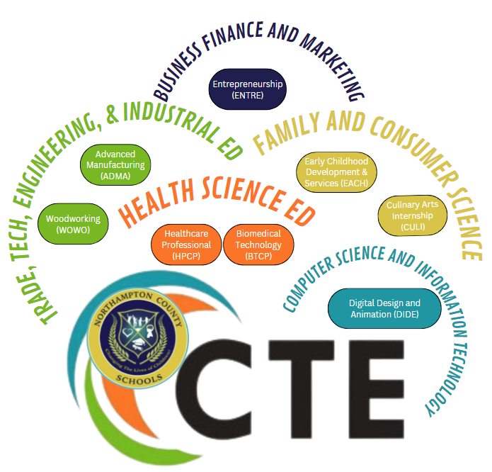

CAREER-TECHNICAL STUDENT ORGANIZATIONS (CTSO) are organizations for individuals enrolled in career development programs and are designed and conducted as an integral part of instruction. They contribute significantly to the motivation, education, and total development of the students through activities that develop leadership skills, citizenship skills, social competencies, and a wholesome attitude about life. Students are encouraged to join the career-technical student organization associated with their career choice.

In addition, with the state articulation agreement, students who score a 90 or above on their CTE post-assessment and have a grade of A or B in the course can receive community college credit for certain courses. High School career development counselors can help students identify these courses. Students taking CTE courses are encouraged to complete a pathway of courses that connect to a post secondary opportunity which is noted by becoming a “CTE Concentrator” and possibly becoming a “CTE Completer”. “Concentrator” students will complete at least 2 courses within the pathway. “Completer” students complete 3 or more courses that allow the student to earn 4 or more credits including an advanced course (level 3 or level 4) or complete a certificate (CCP) within an approved program of study.

*\*\* Indicates CTE Concentrator Course*

## Business Management and Administration Education

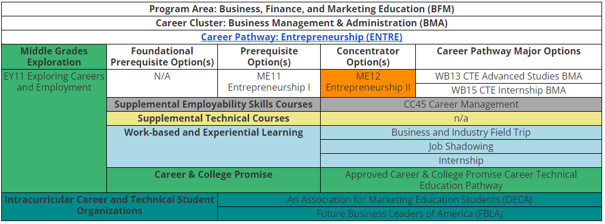

### ENTREPRENEURSHIP I - ME112X0 (NCEC)

Prerequisite: None Length: 1 Semester Credit: 1

**Description:** In this course, students evaluate the concepts of going into business for themselves and working for or operating a small business. They become acquainted with channel management, pricing, product/service management, and promotion. Emphasis is on the exploration of feasible ideas of products/services, research procedures, business financing, marketing strategies, and access to resources for starting a small business. Students will be introduced to the Lean Canvas Business Model (LCBM) throughout the course. A performance based measurement will be used in this course to assess student learning. English language arts and social studies are reinforced. Credential Opportunity: Venture Entrepreneurial Expedition

### **ENTREPRENEURSHIP II HONORS - ME125X0 (NCEC)

Prerequisite: Entrepreneurship l Length: 1 Semester Credit: 1

**Description:** In this course, students continue the development of a business idea and develop an understanding of pertinent decisions to be made for business positioning, financing, staffing, and profit planning. Students acquire in-depth understanding of business regulations, risks, management, and marketing and will develop a business plan. A performance based measurement will be used in this course to assess student learning. English language arts, mathematics, and social studies are reinforced. Credential Opportunity: Entrepreneurship and Small Business Certification Exam

### BUSINESS ESSENTIALS - BF102X0 (NCEC)

Prerequisite: None Length: 1 Semester Credit: 1

**Description**: This course will introduce students to realistic business and finance principles by examining fundamental economic concepts, the business environment, and primary business activities. Through workplace scenarios and problem-based learning, students will explore business ethics, customer relations, economics, financial analysis, human resources management, information management, marketing, operations, and business technology.

### CTE ADVANCED STUDIES BMA - WB132X0 (NCHS)

Prerequisite: Two technical credits in one Career Pathway Length: 1 Semester Credit: 1

**Description:** This culminating course is for juniors and seniors who have earned two technical credits, one of which is a completer course, in one Career Pathway. The Advanced Studies course must augment the content of the completer course and prepare students for success in transitioning to postsecondary education and future careers. Students work under the guidance of a teacher with expertise in the content of the completer course in collaboration with community members, business representatives, and other school-based personnel. The four parts of the course include writing a research paper, producing a product, developing a portfolio, and delivering a presentation. Students demonstrate their abilities to use 21st century skills.

Competitive events, community service, and leadership activities provide the opportunity to apply essential standards and workplace readiness skills through authentic experiences.

### CTE INTERNSHIP BMA - WB152X0 (NCHS)

Prerequisite: None

Length: 1 Semester Credit: 1

**Description:** A CTE Internship allows for additional development of career and technical competencies within a general career field. Internships allow students to observe and participate in daily operations, develop direct contact with job personnel, ask questions about particular careers, and perform certain job tasks. This activity is exploratory and allows the student to get hands-on experience in a number of related activities. The teacher, student, and the business community jointly plan the organization, implementation, and evaluation of an internship, regardless of whether it is an unpaid or paid internship.

## Career Development Education

### CAREER MANAGEMENT - CC452X0 (NCHS, NCEC)

Prerequisite: None Length: 1 Semester Credit: 1

**Description:** This course prepares students to locate, secure, keep, and change careers. Emphasis is placed on self-assessment of characteristics, interests, and values; education and career exploration; evaluation of career information and creation of a career plan. Based on the National Career Development Guidelines, skills learned in this course include, but are not limited to communications, interpersonal skills, problem solving, personal management and teamwork. English language arts is reinforced. Student participation in Career and Technical Student Organization (CTSO) competitive events, community service, and leadership activities provide the opportunity to apply essential standards and workplace readiness skills through authentic experiences. Credential Opportunity: Conover Credential Workplace Readiness

## Health Science Education

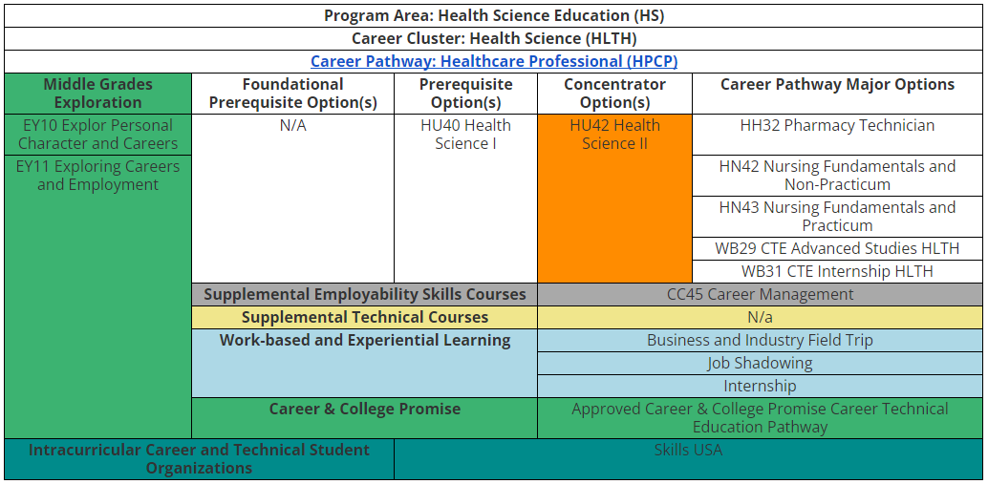

### FOUNDATIONS OF HEALTH SCIENCE - HU102X0 (NCHS)

Prerequisite: None Length: 1 Semester Credit: 1

**Description:** This course is designed to assist potential health care workers in their role and function as health team members. Topics include medical terminology, the history of health care, healthcare agencies, ethics, legal responsibilities, health careers, holistic health, health care trends, cultural awareness, communication, medical math, leadership, and career decision making. English language arts are reinforced.

#### HEALTH SCIENCE l - HU402X0 (NCHS)

Prerequisite: None Length: 1 Semester 1 Credit: 1

**Description:** This course is developed to focus on human anatomy, physiology and human body diseases and disorders, and recognizing and responding to first aid emergencies. Students will learn about healthcare careers within the context of human body systems. Projects, teamwork, and demonstrations serve as instructional strategies that reinforce the curriculum content. English language arts and science are reinforced in this course.

Articulation Credit: MED 121 Medical Terminology I and MED 122 Medical Terminology II. Must make an A or B in the course and score a 93 or better on the exam. Credential Opportunity: First Aid

### **HEALTH SCIENCE II - HU422X0 (NCHS)

Prerequisite: Health Science l Length: 1 Semester Credit: 1

**Description:** This course is developed to help students expand their understanding of the healthcare industry; including: employability skills, safety and infection control procedures, and clinical skills used by allied health professionals. In addition, students will demonstrate their understanding of the cardiovascular and respiratory systems by applying BLS CPR skills. Projects, teamwork, and demonstrations serve as instructional strategies to reinforce the curriculum content. English language arts and science are reinforced in this course.

Articulation Credit: HSC 110 Orientation to Health Careers and CPR Certification. Must make an A or B in course and score a 93 or better on the exam. Credential Opportunity: Basic Life Support, OSHA 10-Hour Industry Certification (Healthcare), and Stop the Bleed.

### 

### **BIOMEDICAL TECHNOLOGY HONORS - HB115XO (NCHS)

Prerequisite: Health Science l Length: 1 Semester Credit: 1

**Description:** This course challenges students to investigate current trends in health care. Topics include ethics, forensic medicine, infectious diseases, organ transplants, cell biology and cancer, and biomedical research. English language arts and science are reinforced in this course. Credential Opportunity: OSHA 10-Hour Industry Certification (Healthcare).

### CTE ADVANCED STUDIES HLTH - WB292X0 (NCHS)

Prerequisite: Two technical credits in one Career Pathway Length: Credit: 1

**Description:** This culminating course is for juniors and seniors who have earned two technical credits, one of which is a completer course, in one Career Pathway. The Advanced Studies course must augment the content of the completer course and prepare students for success in transitioning to postsecondary education and future careers. Students work under the guidance of a teacher with expertise in the content of the completer course in collaboration with community members, business representatives, and other school-based personnel. The four parts of the course include writing a research paper, producing a product, developing a portfolio, and delivering a presentation. Students demonstrate their abilities to use 21st century skills.

Competitive events, community service, and leadership activities provide the opportunity to apply essential standards and workplace readiness skills through authentic experiences.

# 

# 

# 

# Computer Science and Information Technology Education

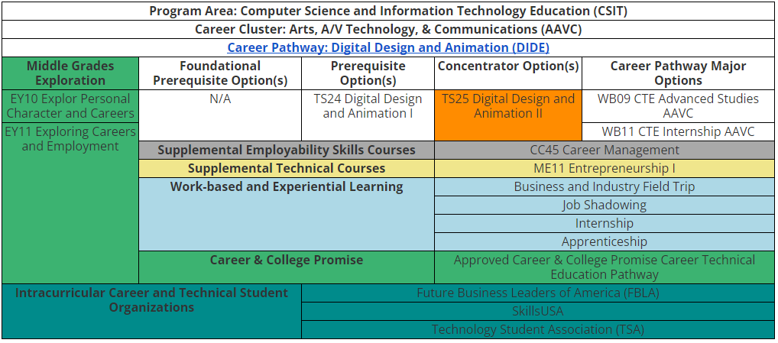

**DIGITAL DESIGN AND ANIMATION I-TS242X0 (NCHS)**

Prerequisite: None Credit: 1

**Description:** This course is an introductory level course focusing on the concepts and tools used by digital artists in a wide variety of creative careers including graphic design, film, and game design. Students work with professional-grade creative software packages to develop 2D and 3D digital graphics and audio/video media. Students use Adobe CC Suite, and digital 3D modeling with 3DS Max to build needed skills for subsequent courses. English language arts, mathematics, and science are reinforced.

**\*\*DIGITAL DESIGN AND ANIMATION II-TS252X0 (NCHS)**

Prerequisite: TS24 Digital Design and Animation I Credit: 1

**Description:**  This course emphasizes the use of industry-standard digital technology and media to help students develop the artistic and technical skills necessary to plan, analyze, and create visual solutions to 21st Century communications problems. Students engage in digital art activities using professional grade creative software packages to develop complex 2D and 3D digital graphics and audio/video media. Students apply Adobe CC Suite and 3DS Max skills to industry-related activities and projects, mirroring workplace scenarios. English language arts, mathematics, and science are reinforced. Credential Opportunity: Autodesk Certified User 3DS Max & Autodesk Certified User Maya.

**Family and Consumer Sciences Education**

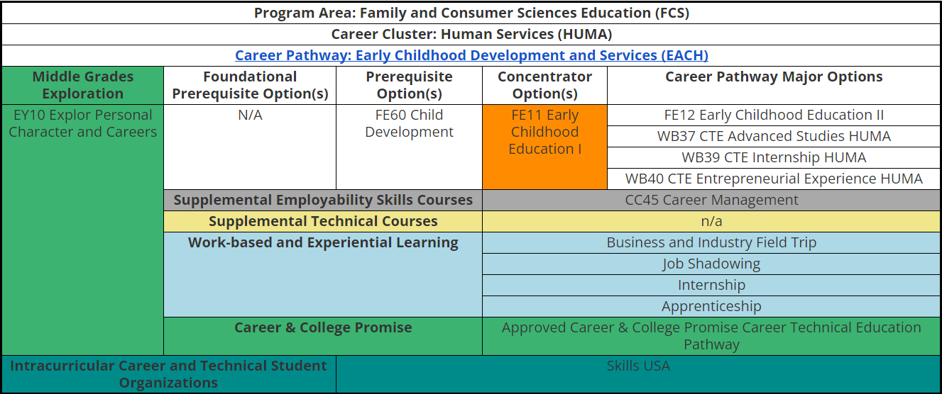

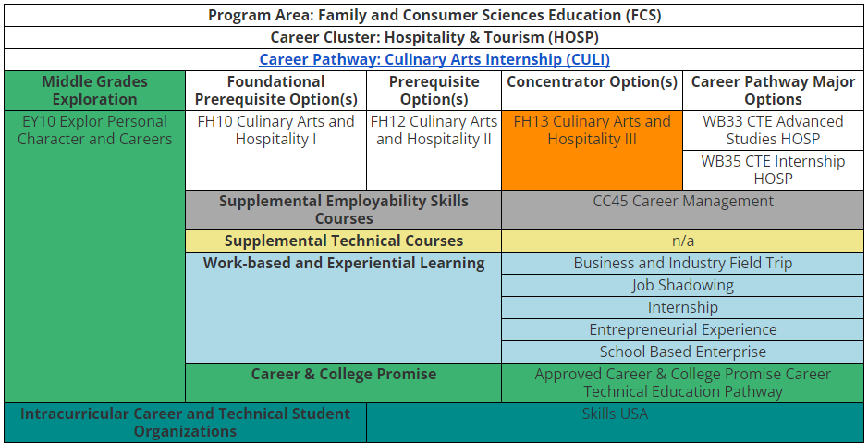

**Culinary Arts and Hospitality I -FH102X0 (NCHS)**

Prerequisite: None Credit: 1

**Description:** This course is designed to introduce students to the hospitality and food service industry by learning about components of professional practice and building basic knowledge and skills in food preparation, garde manger, baking, and food service operations. The introduction includes students learning food safety, breakfast cookery, salads and sandwiches, quick breads and cookies, and dining room service. Art, English language arts, mathematics, science, and social studies are reinforced. Credential Opportunity: ANSI-Accredited Food Protection Manager Certification (ServSafe)

* For safety reasons, enrollment should not exceed 20 students.

**Culinary Arts and Hospitality II Internship- FH126X0 (NCHS)**

Prerequisite: FH10 Culinary Arts and Hospitality I Credit: 1

**Description:** This course is designed for students to demonstrate their knowledge and skills in basic food preparation, garde manger, baking and foodservice operations by planning and executing the program’s school-based enterprise. The experience includes students preparing and selling breakfast items, salads and sandwiches, and quick breads and cookies while applying safety, sanitation, and guest service skills. Arts, English and language arts, mathematics, science, social studies, and are reinforced. Credential Opportunity: ANSI-Accredited Food Protection Manager Certification (ServSafe)

* For safety reasons, enrollment should not exceed 20 students.

**\*\*Culinary Arts and Hospitality III-FH132X0 (NCHS)**

Prerequisite: FH10 Culinary Arts and Hospitality I Credit: 1

**Description:** This course is designed for students to demonstrate their knowledge and skills in basic food preparation, garde manger, baking and foodservice operations through mentored work experiences in the food service industry. The experience includes students preparing and selling breakfast items, salads and sandwiches, and quick breads and cookies while applying safety, sanitation, and guest service skills. Arts, English and language arts, mathematics, science, and social studies are reinforced. Credential Opportunity: Certified Fundamentals Cook (CFC) & Pre-Professional Assessment and Certification in Culinary Arts.

* For safety reasons, enrollment should not exceed 20 students.

**Child Development -FE602X0 (NCHS)**

Prerequisite: None Credit: 1

**Description:** This course introduces students to responsible nurturing and basic application of child development theory, focusing on prenatal development through children age 5. Areas of study include the effects of family on individuals and society; prenatal development and care; and understanding how children develop physically, cognitively, emotionally, and socially.

**\*\* Early Childhood Education I Honors- FE115X0 (NCHS)**

Prerequisite: FE60 Child Development. Credit: 1

**Description:** This two-credit course prepares students to work with children in early childhood education settings. Topics of study include historical, theoretical, and philosophical foundations of the profession, the structure of early childhood programs, connecting appropriate learning activities and teaching strategies to developmental needs of children, inclusive environments, communicating expectations, setting limits, and guiding behavior, as well as personal growth in the field of child development. An internship makes up 50 percent of instructional time. Due to student participation in internships at early childhood centers that are licensed by the Division of Child Development and Early Education, students must be 15 years of age before September 1. Credential Opportunity: CPR/AED, First Aid & North Carolina Early Childhood Credential (NCECC) Equivalency.

* For safety reasons and intern placement, enrollment should not exceed 20 in this course.

**Early Childhood Education II Honors- FE125X0 (NCHS)**

Prerequisite: FE11 Early Childhood Education I Credit: 1

**Description:** Discover characteristics for effective early childhood education activities. Prepare high quality instructional materials and activities for early childhood classrooms. Create engaging lesson plans for children birth to age 12. Gain the knowledge and skills for careers in the early childhood education pathway. Credential Opportunity: CPR/AED, First Aid & North Carolina Early Childhood Credential (NCECC) Equivalency.

**Trade, Technology, Engineering, and Industrial Education**

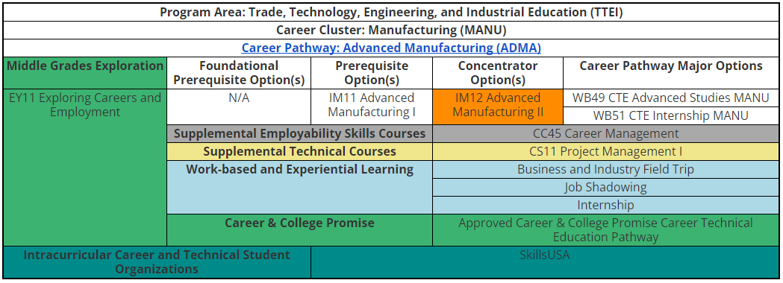

**Advanced Manufacturing I-IL382X0**

Prerequisite: None Credit: 1

**Description:** In this course, students will be exposed to the principles, processes, and career choices related to manufacturing. Students will learn blueprint reading, mechanism technologies, the various types of fasteners and tools utilized in industrial manufacturing, as well as fundamentals of electronics. Students will also learn the theories and programming behind Programmable Logic Controllers (PLCs) and their applications to industrial applications Credential Opportunity: Certified Production Technician (CPT) & Safety, & Certified Production Technician (CPT)- Maintenance Awareness (Must pass both), and OSHA 10-Hour General Industry (Manufacturing) Certification

**\*\*Advanced Manufacturing II - IL392X0**

Prerequisite: Advanced Manufacturing I Credit: 1

**Description:** In the second level manufacturing course, students will learn lean manufacturing and industrial safety techniques, as well as OSHA regulations in a manufacturing environment. In addition, students learn the foundations of mechanical measurement and quality control, basic concepts of electricity, and electrical control. Students will apply theory and programming of Programmable Logic Controllers (PLCs) at an advanced level. Credential Opportunity: Certified Production Technician (CPT) - Manufacturing Processes and Production & Certified Production Technician (CPT) - Quality Practices and Measurement.

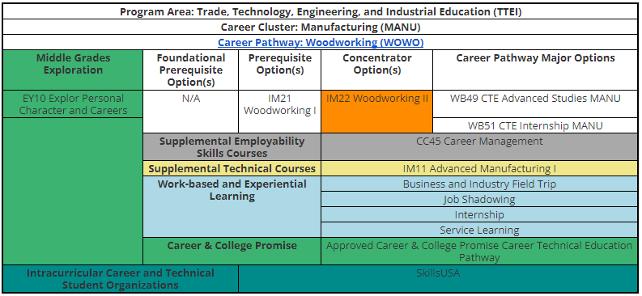

**Woodworking I - IM212X0C**

Prerequisite: None Credit: 1

**Description:** This course introduces career information, employment opportunities, and skills required for work in the woodworking and cabinetmaking industry. Topics include the woodworking industries, health, and safety design and layout, materials, hand tools, power tools, portable and stationary, preparation, construction and assembly, and finishing. English language arts and mathematics are reinforced. *Due to potentially hazardous processes and equipment a maximum enrollment of 20 is recommended. Credential Opportunity: OSHA 10-Hour Construction Industry Certification

**Woodworking II Honors - IM225X0**

Prerequisite: Woodworking I Credit: 1

**Description:** The course teaches the development of knowledge and advanced skills in the woodworking and cabinetmaking industry. Emphasis is placed on advanced principles applied to the woodworking and cabinetmaking industry. Topics include advanced levels of the cabinet making industry, health and safety, design and layout, materials, hand tools, power tools, portable and stationary, preparation, construction and assembly, and finishing. English language arts and mathematics are reinforced. *Due to potentially hazardous processes and equipment a maximum enrollment of 20 is recommended. Credential Opportunity: Woodwork Career Alliance (WCA) Sawblade Certificate OSHA 10-Hour Construction Industry Certification

**SPECIAL INTEREST TOPICS**

### TEACHER CADET I HONORS – 96045XO (NCEC)

Prerequisites: None Length: 1 Semester

Credit: 1

**Description:** Early College Teacher Cadet I scholars begin to develop the knowledge, skills, and dispositions needed to become exemplary teachers.

### TEACHER CADET II HONORS – 96065XO (NCEC)

Prerequisites: Teacher Cadet I Honors Length: 1 Semester

Credit: 1

**Description:** Early College Teacher Cadet II scholars continue to develop the knowledge, skills, and dispositions from the previous course with additional emphasis on leadership development, pedagogy, and personal development.

### ACT PREP –96072X0 (NCHS, NCEC)

Prerequisites: None Length: 1 Semester

Credit: 1

**Description:** In this ACT Seminar, scholars develop study skills, explore test taking strategies, increase writing levels, and strengthen reading stamina to globally compete with other students who are taking the college entrance exam.

### LOCAL ELECTIVE HONORS SEMINAR –96105OSEM (NCHS, NCEC)

Prerequisites: None Length: 1 Semester

Credit: 1

**Description:** Early college scholars taking seminars engage in project-based learning, service learning, and the Early College Reads Program.

### FRESHMAN SEMINAR - 96102X0FS (NCEC)

Prerequisites: 9th grade student Length: 1 Semester/Year-Long

Credit: 1

**Description:** Freshman Seminar exposes scholars to the social and academic skills they need to be successful in high school. Students practice note-taking, time management, study, social, and human relation skills. This provides them with a mindset to become global citizens and initiate change within their community. They learn more about themselves through exploration of post-secondary education and career options.

**EXCEPTIONAL CHILDREN**

The Future Ready Core Occupational Course of Study program (OCS) is designed to provide a sound foundation in preparation for adult living for students with disabilities. Through participation in a vocationally oriented curriculum and in relevant work experiences, students learn skills necessary to enter the world of work, retain employment, and seek other employment throughout their adult lives. The OCS program is designed for eligible students as determined by the IEP Team and their individual skills needed to develop a foundation for work. This course of study consists of three components: (1) academic requirements (2)school and community-based work hour requirements (3) Career Portfolio. The program addresses the aptitudes that are necessary for successful adult living and employment. Course work within this pathway emphasizes integration into the working community after high school graduation.

The Occupational Course of Study is intended to meet the educational and career development needs of a small group of students with disabilities who require a variety of substantive instructional supports and accommodations throughout the school day to access and make progress towards grade-level standards. The vast majority of students with disabilities participate in and complete the Future Ready Core Standard Course of Study (FRC-SCOS) with the use of accommodations and supplemental aids and services as outlined in the student’s IEP. However, the focus of OCS is to prepare students to go directly into employment with marketable skills or to attend a postsecondary education program resulting in licensure or credential upon graduation from high school.

**Students are required to complete 22 Credit hours plus any other credits required by the local district to graduate with a North Carolina diploma.**

These course requirements apply to students **entering the 9th grade for the first time in 2021- 2022** and are contained in Section II of the GRAD-004 policy. See the Northampton County Graduation Requirements page of this course guide for more details.

**OCS English**

## English I

Course #: 9210BX0 Credits: 1 Prerequisite(s): None

**Description:**  This course covers standards in the areas of communication, language and meaning, critical thinking, and research. Students will use the writing process to develop a product and understand appropriate presentation skills. Use of a variety of strategies to comprehend texts and understand appropriate language and conventions in all forms of communication will be a focus in the course. Students will be expected to analyze cause and effect relationships in literature and real life, analyses of cause and effect relationships in literature and real life, and analyses of events in the context of culture and literature. Students will develop an understanding of literary elements and rhetorical techniques as well as literary and informational texts. Application of research tools and techniques to selected topics will be presented. *At select schools the course is taught in a blended learning environment with collaborative instruction delivered by an online highly-qualified English teacher as well as face-to-face OCS teacher.

## English II

Course #: 9211BX0 Credits: 1 Prerequisite(s): English I

**Description:** This course covers standards in the areas of oral and written communication, language and meaning, critical thinking and research in a more complex manner. Students will create increasingly complex oral and written responses for a variety of audiences, purposes, and contexts. The learner will use these skills in the development of presentations. Students will use a variety of strategies to comprehend text, and use appropriate language and conventions in all forms of communications. Analyses of texts in visual, auditory, and digital formats will be taught. Students will create research studies focusing on global issues and create oral, written, and visual products focusing on global issues. At the completion of this course, students must be assessed using the English II EOC with documented accommodations and modifications. *At select schools the course is taught in a blended learning environment with collaborative instruction delivered by an online highly-qualified English teacher as well as a face-to-face OCS teacher.

## English III

Course #: 9212BX0 Credits: 1 Prerequisite(s): English II

**Description:** This course covers standards in the areas of communication, language and meaning, critical thinking and research through multifaceted approaches. Students will develop an understanding of literary and informational texts. They will use appropriate communication skills in employment, post-secondary education/training and independent living settings and be able to create written products using a template or form. Focusing on post-secondary education/training and independent living, the student will apply reading and comprehension strategies to informational texts in the specific domains. The learner will carry out a problem-solving process as it relates to personal life situations and apply the knowledge of cause and effect to decision making. The course will summarize the importance of forming a viewpoint in situations related to adult living. *At select schools the course is taught in a blended learning environment with collaborative instruction delivered by an online highly- qualified English teacher as well as a face-to-face OCS teacher.

## English IV

Course #: 9213BX0 Credits: 1 Prerequisite(s): English III

**Description:** This course covers standards in the areas of communication, language and meaning, critical thinking and research through comprehensive methodologies. Students will apply information from literary and informational texts to carry out adult -living tasks and activities. They will communicate options that can be used to a variety of audiences. The course requires the student to construct written products without reliance on templates and/or forms and apply reading comprehension strategies to informational texts found in employment, post-secondary education/training, and independent living domains. The course requires the student to develop plans to solve problems that occur in adult life, while being able to attribute the impact of cause and effect on a given real life problem and to generate a viewpoint based on current events in written text or personal life situations. *At select schools the course is taught in a blended learning environment with collaborative instruction delivered by an online highly qualified English teacher as well as a face-to-face OCS teacher

**OCS Mathmatics**

## 

## Introduction to Mathematics I

Course #: 9220BX0 Credits: 1 Prerequisite(s): None

**Description:**  This course covers number and operations, geometry, measurement, algebra, statistics and probability. It uses the core standards so students can understand rational numbers, apply mathematical operations with rational numbers, and apply ratios, proportions and percentages to solve problems. Students will use time and measurement to solve problems. Algebraic properties will be used to solve problems and to understand patterns and relationships. Students will develop an understanding of data in terms of graphical displays, measure of center and range. *At select schools the course is taught in a blended learning environment with collaborative instruction delivered by an online highly-qualified math teacher as well as a face-to-face OCS teacher.

## NC Math I

Course #: 9225BX0 Credits: 1 Prerequisite(s): Introduction to Mathematics I

**Description:** This course uses the core standards to provide students a more complex mathematical curriculum. Following the format studied in Introduction to Mathematics, the course covers number and operations, geometry, measurement, algebra, statistics and probability, while adding the area of discrete algebra. Students will be required to use ratios and rates to solve problems and use properties of exponents to simplify expressions. They will use properties and strategies to combine and factor algebraic expressions, use direct and indirect variations to solve problems, analyze patterns of change in functional relationships, understand functions based on mathematical and real world phenomena, and use strategies to find solutions for linear and exponential relationships. They will be required to analyze properties of geometric shapes in the Cartesian coordinate system and use formulas to solve problems involving area and volume. They will analyze statistical distributions in terms of the relationships among shape, center, spread and outliers and infer trends in bivariate data. Students will use vertex-edge graphs to route and optimize critical paths. *At select schools the course is taught in a blended learning environment with collaborative instruction delivered by an online highly-qualified math teacher as well as a face-to-face OCS teacher.

## Financial Management

Course #: 9222BX0 Credits: 1 Prerequisite(s): NC Math I

**Description:** This course focuses on the application of skills needed for independent living. Emphasis is placed on financial management and planning. Students will develop an understanding of state and federal income taxes, wages compensation, and the use of credit. They will be introduced to different types of insurance to meet personal needs while applying math skills to consumer spending. *At select schools the course is taught in a blended learning environment with collaborative instruction delivered by an online highly-qualified math teacher as well as a face-to-face OCS teacher.

## Employment Preparation IV Math

Course#: 9265BX0 Credits: 1 Prerequisite (s): Employment Preparation I, II, III

**Description:** Purpose: This course is designed to teach students skills and promote success in the areas of postsecondary education, employment, and independent living. Instructional emphasis will be placed on the application and generalization of skills to post school environments. The Six Employability Skills adopted by NCDPI have been embedded within the competency goals and objectives throughout the course. Employment Preparation courses should be taught in sequential order as the content is designed to help the student build their skills and increase their depth of knowledge levels over grades 9-12. Students will receive direct instruction in the competency goals and objectives during class time and will be expected to apply appropriate skills within the naturally occurring setting during activities associated with school-based hours, community based hours, and paid employment hours

required by the GRAD-004 policy to be completed by graduation.

**OCS Science**

## Applied Science

Course #: 9231BX0 Credits: 1 Prerequisite(s): None

**Description:** This course covers core standards in forces and motion, energy, electricity and magnetism, matter, chemicals, and the environment. Through course design the students will learn concepts and describe attributes associated with weight, mass, and types of force. Energy and conservation will be defined with an explanation of related effects. Students will develop an understanding of electricity and magnetism as well as the properties of matter. They will identify the uses and dangers of common chemicals. The course covers how humans can have positive and negative effects on the environment. Students will develop an understanding of the human body’s basic needs and control systems (including common health indicators). *At select schools the course is taught in a blended learning environment with collaborative instruction delivered by an online highly-qualified science teacher as well as a face-to-face OCS teacher.

## Biology

Course #: 9232BX0 Credits: 1 Prerequisite(s): Applied Science

**Description:**  This course covers standards in the areas of structure and functions of living organisms, evolution & genetics, and molecular biology. Students will understand the relationship between the structures and functions of cells and their organelles and the analysis of the cell as a living system. Students will explore the interdependence of living organisms within their environment and learn the impact of human activities on the environment generation to generation. The course explains how traits are determined by the structure and function of DNA and how the environment, and/or the interaction of alleles, influences the expression of genetic traits, as well as the application of DNA technology. The theory of evolution by natural selection as a mechanism for how species change over time is covered, including how classification systems are developed based upon speciation. Students will develop an understanding of how biological molecules are essential to the survival of living organisms. They will analyze the relationship between biochemical processes and energy use. At the completion of the course, the student must be assessed using the Biology EOC with documented accommodations and modifications. *At select schools the course is taught in a blended learning environment with collaborative instruction delivered by an online highly-qualified science teacher as well as a face-to-face OCS teacher.

## 

## Employment Preparation 1 Science

Course #: 9260BX0 Credits: 1 Prerequisite (s): None

**Description:** The content focus is employability skills, self-awareness, self-determination, self-advocacy, technology, health/safety, career development and planning, personal management and includes elements of the nature of science. This course is designed to teach students skills and promote success in the area of postsecondary education employment and independent living. The structural emphasis will be placed on the application and generalization of skills to post school environments. The six employability skills adopted by NCDPI have been embedded within the competency goals and objectives throughout the course. This includes the 150 school based hours to be completed by the 12th grade year in school.

**OCS Social Studies**

## Founding Principles of USA and NC: Civic Literacy

Prerequisite (s): None Course #: 9251BX0 Credits: 1

**Description**: The standards and objectives in the Founding Principles of the United States of America and North Carolina: Civic Literacy course will provide students the opportunity to engage in intensive application of the skills, concepts, processes, and knowledge gained in previous social studies courses and prepare them to be college, career, and civic ready. Despite there being a different overall focus for each subsequent course, students will explore the content through the following lenses: inquiry; behavioral sciences; civics and government; economics; geography; and history. As students develop cognitively, these lenses become more focused based on the grade-level content and disciplinary thinking skills.

## Economics and Personal Finance

Prerequisite (s): Founding Principles of USA and NC: Civic Literacy Course #: 43192X0 Credits: 1

**Description**: The standards and objectives in the Economics and Personal Finance course will provide

students the opportunity to engage in intensive application of the skills, conge, career, and civic ready.

## Employment Preparation II: Citizenship 1A (to include 75 work hours) *Concepts, processes, and knowledge gained in previous social studies courses and prepare them to be college and career ready*

Prerequisite (s): Employment Preparation I Course #: 9261BX0

**Description**: This course is designed to teach students skills and promote success in the areas of postsecondary education, employment, and independent living. Instructional emphasis will be placed on the application and generalization of skills to post school environments. The Six Employability Skills adopted by NCDPI have been embedded within the competency goals and objectives throughout the course. Employment Preparation courses should be taught in sequential order as the content is designed to help the student build their skills and increase their depth of knowledge levels over grades 9-12. Students will receive direct instruction in the competency goals and objectives during class time and will be expected to apply appropriate skills within the naturally occurring setting during activities associated with school-based hours, community based hours, and paid employment hours required by the GRAD-004 policy to be completed by graduation.

## Employment Preparation II: Citizenship 1B (to include 75 work hours)

Prerequisite (s): Employment Preparation 1, and II (Citizenship 1A) Course #: 9262BX0

**Description**: This course is designed to teach students skills and promote success in the areas of

postsecondary education, employment, and independent living. Instructional emphasis will be placed on the

application and generalization of skills to post school environments. The Six Employability Skills adopted by

NCDPI have been embedded within the competency goals and objectives throughout the course. Employment

Preparation courses should be taught in sequential order as the content is designed to help the student build

their skills and increase their depth of knowledge levels over the grades 9-12. Students will receive direct

instruction in the competency goals and objectives during class time and will be expected to apply

appropriate skills within the naturally occurring setting during activities associated with school-based hours,

community based hours, and paid employment hours required by the GRAD-004 policy to be completed by

graduation.

**OCS Health/Physical Education**

## Health and Physical Education

Prerequisite (s): None Course #: **60492X0** Credits: 1

**Descriptions:** Students are required to successfully complete CPR instruction to meet Healthful Living Essential Standards as a requirement for high school graduation. Accommodations/alternative assessments for students identified by ADA or IDEA will be provided.

**OCS Career and Technical Education**

## 4 CTE Elective Credits (see Career and Technical Education)

**Additional OCS Credits**

## Two Additional Employment Preparation Education credits

Prerequisite (s): Employment Preparation 1 and II

Course #: Credits:

Description:

* **Employment Preparation III: Citizenship II A** (to include 75 work hours)/ Course #: 9263BX0
* **Employment Preparation III: Citizenship II B** (to include 75 work hours)/Course #: 9264BX0

## PLEASE FIND THE CREDIT REQUIREMENTS FOR ELIGIBLE STUDENTS ENTERING 9TH GRADE FOR THE FIRST TIME FOR THE RESPECTIVE YEARS AT THE FOLLOWING LINK:

## [FOR ELIGIBLE STUDENTS WHO ENTERED GRADE 9 FOR THE FIRST TIME IN 2020-2021](https://simbli.eboardsolutions.com/Policy/ViewPolicy.aspx?S=10399&revid=ZmtSIvk4vLqVplusCQ94FREhg%3d%3d&PG=6&st=grad-004&mt=Any)

## [FOR ELIGIBLE STUDENTS WHO ENTERED GRADE 9 FOR THE FIRST TIME between 2017-2018 and 2019-2020](https://simbli.eboardsolutions.com/Policy/ViewPolicy.aspx?S=10399&revid=ZmtSIvk4vLqVplusCQ94FREhg%3d%3d&PG=6&st=grad-004&mt=Any)

**North Carolina Extended Content Standards**

## The other Extended Content Standard Leads to Certificate of Graduation. Students in this program of study are able to participate in the high school graduation ceremony. The Extended Content Standards (ECS) program is designed for students who have a significant cognitive disability. Students enrolled in ECS are assessed on achievement in an alternate curriculum using the North Carolina Extend Assessment.

The NC Extended Content Standards are based on the Standard Course of Study, but extend to meet the instructional needs of students with moderate to significant cognitive disabilities. Each student on the NCECS is expected to access the entire curriculum. Each student accesses the curriculum at his/her grade level. The NCECS is a modified curriculum that allows for a variety of accommodations.

**\*Students entering 9th Grade in 2021-2022 must take the following courses to meet state requirements for receiving a Certificate of Graduation. Information can be found at the following link: at:**[**https://www.ecac-parentcenter.org/wp-content/uploads/NC-High-School-Graduation-Requirements.pdf**](https://www.ecac-parentcenter.org/wp-content/uploads/NC-High-School-Graduation-Requirements.pdf)

**Current Requirements**

**4 ECS English Credits:**

• ECS English I

• ECS English II 11th Grade Alternative Assessment (NC EXTEND 1)

• ECS English III

• ECS English IV

**ECS Math:**

11th Grade Alternative Assessment (NC EXTEND 1)

**ECS Science:**

11th Grade Alternative Assessment (NC EXTEND 1)

**Health/PE:** 1 Credit

**Electives & Other Requirements:**

Elective and Career Technical Courses As Appropriate ** Does not participate in State CTE Post Assessments**

**NCDPI Course Guidance Materials for Social Studies and Mathematics**

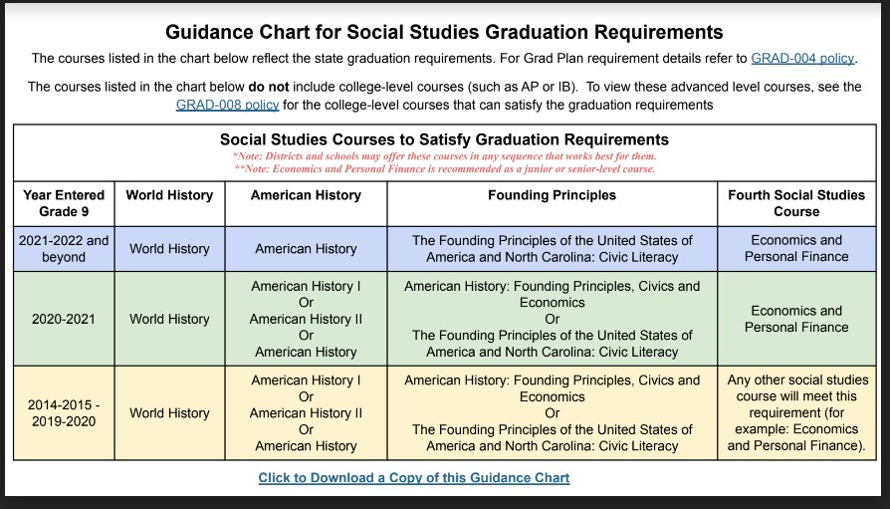

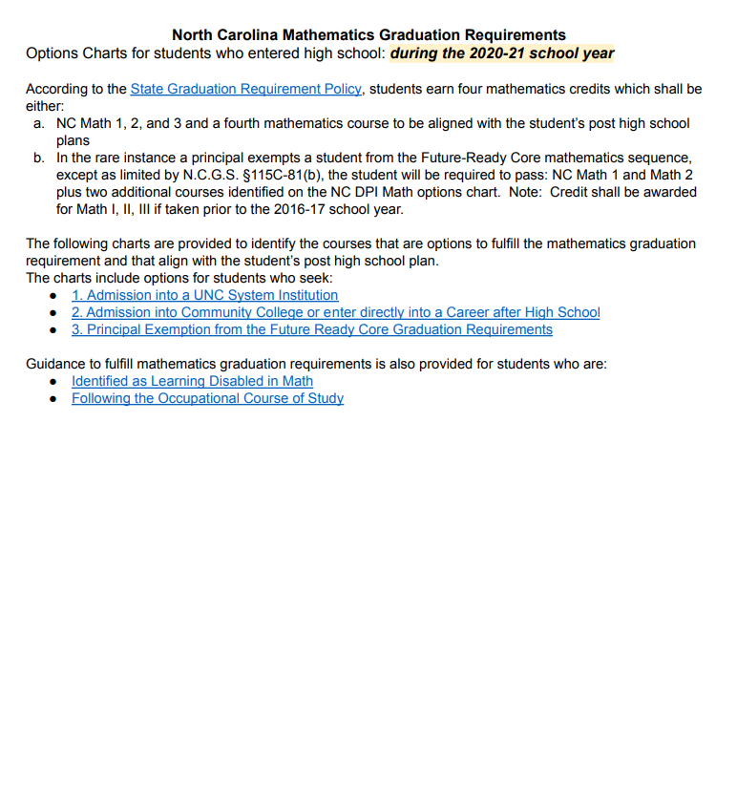

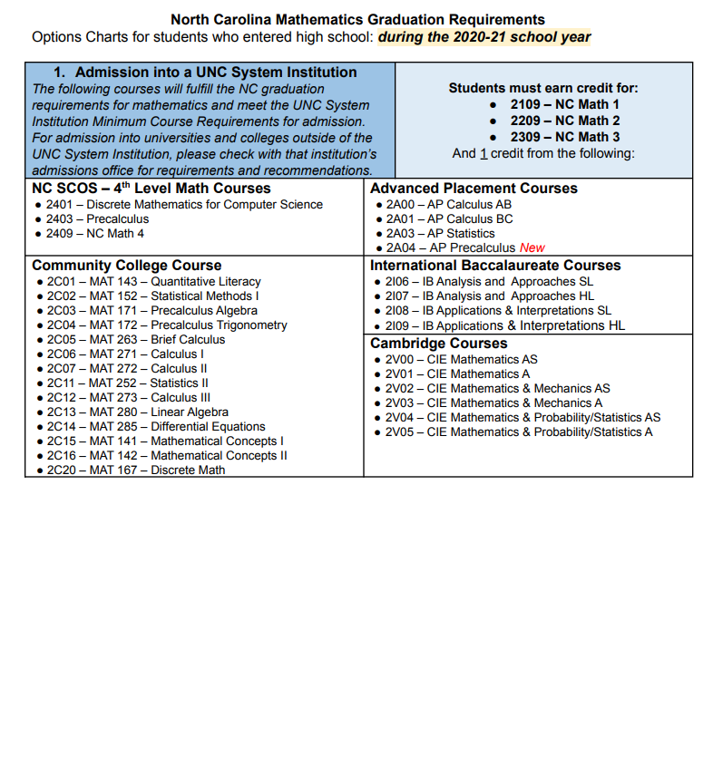

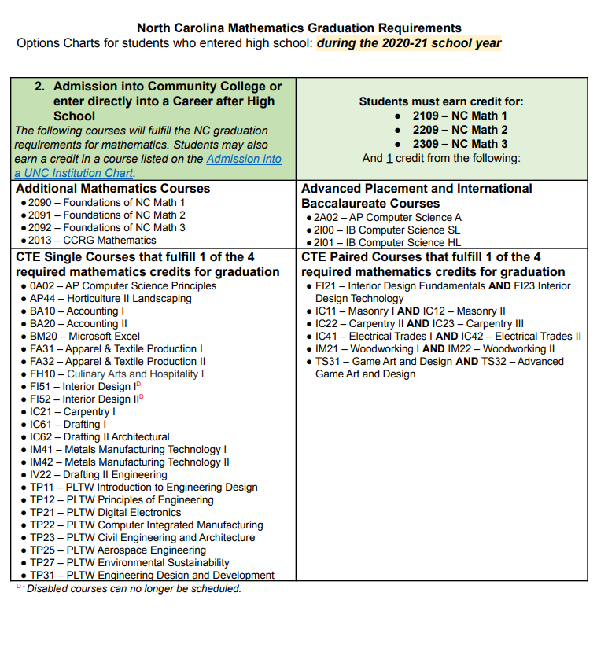

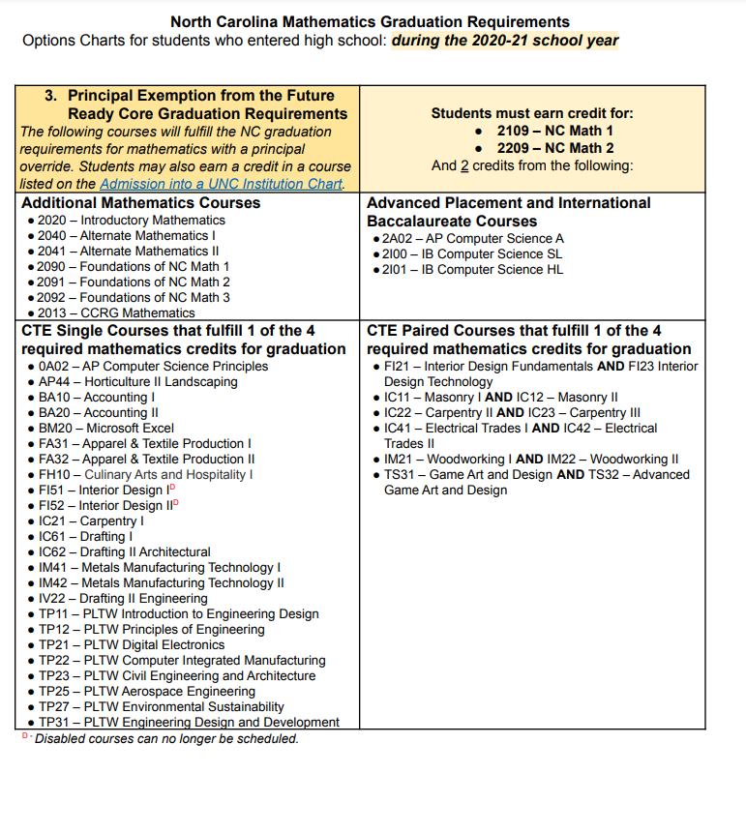

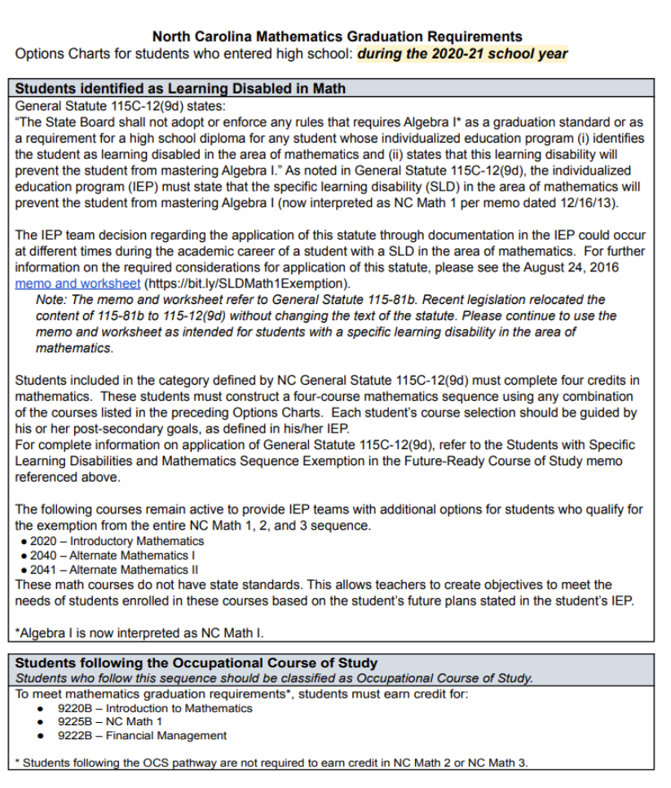

**NORTHAMPTON COUNTY SCHOOLS**

**GRADUATION CHECKLIST**

**Name: ___________________________________ Birth Date:_____________ 9th Grade Entry Year: ____________**

|  |
| --- |
| **Notes:**  **Meeting Dates:** |

**Four Year Plan:**

**______ Four Year College ______ Community College ______ Workforce ______ Military**

|  |
| --- |
| **ENGLISH**  **______**English I _______ English II _________ ENG 111 and 112 _______ English III or ENG 231or ENG 232  ______ English IV or ENG 241 or ENG 242 |
| **MATH**  _____ FOM 1 _____ Math 1 _____ FOM 2 _____ Math 2 _____ FOM 3 _____ Math III _____ Math IV  _____ MAT 143 _____ MAT 152 ______ MAT 171 ______ MAT 172  **Math Options Alternative:** ___________________________ |
| **SCIENCE: __**_____ Earth/Env. _______ Biology (_____ Physical Science or _____ Chemistry) |
| **SOCIAL STUDIES** ______ World History ______ American History ______Civic Literacy _______ Econ&PF |
| **HEALTH & PE _**______ Health/PE ______ CPR (_____ PED 110 and ______ HEA 110) |
| **SPANISH/FOREIGN LANGUAGE**  **_____ Spanish I _____ Spanish II Other: ____________________________________________** |
| **ELECTIVE: 4 (CTE, Arts, JROTC)**   1. **_________________________________ 11. ___________________________________** 2. **_________________________________ 12. ___________________________________** 3. **_________________________________ 13. ___________________________________** 4. **__________________________________ 14. ___________________________________** 5. **__________________________________ 15. ___________________________________** 6. **__________________________________ 16. ___________________________________** 7. **__________________________________ 17. ___________________________________** 8. **__________________________________ 18. ___________________________________** 9. **__________________________________ 19. ___________________________________** 10. **__________________________________ 20. ___________________________________**   **Completer Pathway ______________________________________ _____________________________________** |
| **Total Credit Required for Graduation: 22 Total as of Meeting ___________**  **Notes:** |

**NORTHAMPTON COUNTY SCHOOLS**

**GRADUATION CHECKLIST: Occupational Course of Study**

**Name: ___________________________________ Birth Date:__________ 9th Grade Entry Year: ____________**

|  |
| --- |
| **Notes:**  Meeting Dates: |

**Four Year Plan:**

**_____ Four Year College _____ Community College _____ Workforce _____ Military**

|  |
| --- |
| **ENGLISH**  **______**OCS English I _______ OCS English II _______ OCS English III _________ OCS English IV |
| **MATH**  ______ Intro to Math 1 ______ Math I _____ Financial Management _____Employment Preparation IV Math |
| **SCIENCE:** _____ OCS Applied Science ______ OCS Biology ____ Employment Preparation I Science |
| **SOCIAL STUDIES**  _____Civic Literacy _____ Econ&PF ____Employ. Prep Citiz II IA ____ Employ Prep Citiz II IB |
| **HEALTH & PE _**_____ Health/PE ______ CPR |
| **PREPARATION:**  ____ Employment Preparation III Citizenship II A ____Employment Preparation III Citizenship II B |
| **ELECTIVE: 4 (CTE, Arts, JROTC)**   1. **_________________________________ 7. ___________________________________** 2. **_________________________________ 8. ___________________________________** 3. **_________________________________ 9. ___________________________________** 4. **__________________________________ 10. ___________________________________** 5. **__________________________________ 11. ___________________________________** 6. **__________________________________ 12. ___________________________________**   **Completer Pathway ______________________________________ _____________________________________** |
| **Total Credit Required for Graduation: 22 Total as of Meeting ___________**    **Meetings:** |

# Halifax Community College Graduation Checklist

**Associates of Arts Graduation Checklist**

|  |
| --- |
| **Universal General Education Transfer Component (14 or 15 SH of the required 30 UGETC SH)** |
| **Study Skills ( 1 Semester Hours)**   1. ACA 122 College Transfer Success(1)☐   **English Composition ( 6 semester Hours)**   1. ENG 111 Writing and Inquiry (3)☐ 2. ENG 112 Writing/Research in the Disciplines (3)☐   **Communications (3 Semester Hours)**   1. COM 231 Public Speaking(3)☐   **Mathematics (3-4 Semester Hours)(Choose one course)**   1. MAT 143 Quantitative Literacy (DMA 050 & DRE 098) (3)☐ 2. MAT 171 Precalculus Algebra (DMA 065) (4)☐   **Required General Education (3 Semester Hours)**   1. CIS 110 Introduction to Computers(3)☐ Completed☐ |
| **A. Humanities/Fine Arts - 6 SH Choose 2 courses from two different disciplines (UGETC)** |
| ART 111 Art Appreciation (DRE 098) (3)☐ MUS 110 Music Appreciation(3)☐  ENG 231 American Literature I(3)☐ MUS 112 Introduction to Jazz(3)☐  ENG 232 American Literature II(3)☐ Completed☐ |
| **B. Social and Behavioral Sciences - 9 SH Choose 3 courses from two different disciplines (UGETC)** |
| ECO 251 Principles of Microeconomics(3) ☐ HIS 131 American History I(3)☐ SOC 210 Introduction to Sociology(3)☐  ECO 252 Principles of Macroeconomics(3)☐ HIS 132 American History II(3)☐  HIS 111 World Civilizations I(3)☐ POL 120 American Government(3)☐  HIS 112 World Civilizations II(3)☐ PSY 150 General Psychology(3)☐ Completed☐ |
| **C. Natural Science Options - 8 SH Choose 2 courses** |
| BIO 111 General Biology I(4)☐ & BIO 112 General Biology II (BIO 111) (4)☐  CHM 131 Intro to Chemistry(3)☐ & CHM 131A Intro to Chemistry Lab(1)☐  CHM 151 General Chemistry I (4)☐ & CHM 152 General Chemistry II(4)☐  PHY 110 Conceptual Physics (None) (3) ☐ & PHY 110A Conceptual Physics Lab (1)☐ Completed☐ |
| **General Education (UGETC) - 13 -14 SH Choose courses from this list that have not be previously used:**  **Courses in this list will be accepted at any UNC System institution for transfer:** |
| ART 111 Art Appreciation (DRE 098) (3)☐ HIS 111 World Civilizations(3)☐ MAT 143 Quantitative Literacy(3)☐  BIO 111 General Biology I (DRE 098) (4) ☐ HIS 112 World Civilizations II(3)☐ MAT 152 Statistical Methods I(3)☐  BIO 112 General Biology II (BIO 111) (4)☐ ENG 231 American Literature I(3)☐ MAT 171 Precalculus Algebra(4)☐  CHM 151 General Chemistry I (4)☐ ENG 232 American Literature II(3)☐ PSY 150 General Psychology(3)☐  CHM 152 General Chemistry II(4)☐ MUS 110 Music Appreciation(3)☐ MUS 112 Introduction to Jazz(3)☐ HIS 131 American History I(3)☐ HIS 132 American History II(3)☐ POL 120 American Government(3☐  ECO 251 Principles of Microeconomics(3) ☐ SOC 210 Introduction to Sociology☐  ECO 252 Principles of Macroeconomics(3☐ MAT 172 Pre-Calculus Trigonometry(4)☐  MAT 272 Calculus II (MAT 271) (4)☐ MAT 271 Calculus I (MAT 172) (4) ☐  PHY 110 Conceptual Physics(3)☐ & PHY 110A Conceptual Physics Lab(1)☐ Completed☐ |
| **Elective/Other Required Courses (**non-UGETC): 14 SH**  **Choose courses from this list that have not been previously used:** |
| BUS 110 Intro to Business (3)☐ COM 110 Intro to Communication(3)☐ HUM 120 Cultural Studies(3)☐  HEA 110 Personal Health & Wellness(3)☐ HUM 115 Critical Thinking(3)☐PED 110 Fit & Well for Life(2)☐  SOC 213 Sociology of the Family(3)☐ SOC 220 Social Problems(3)☐ REL 110 World Religions(3)☐  SOC 240 Social Psychology(3)☐ SPA 111 Elementary Spanish I(3)☐ SPA 111 Elementary Spanish II(3)☐  PSY 241 Developmental Psychology (PSY 150) (3)☐ PSY 281 Abnormal Psychology (PSY 150) (3)☐  Completed☐ |

**Associates of Science Graduation**

**Checklist 2023-2024**

|  |
| --- |
| **Universal General Education Transfer Component (14 or 15 SH of the required 30 UGETC SH)** |
| **Study Skills ( 1 Semester Hours)**   1. ACA 122 College Transfer Success(1)☐   **English Composition ( 6 semester Hours)**   1. ENG 111 Writing and Inquiry (3)☐ 2. ENG 112 Writing/Research in the Disciplines (3)☐   **Communications (3 Semester Hours)**   1. COM 231 Public Speaking(3)☐   **Mathematics (3-4 Semester Hours)(Choose one course)**   1. MAT 143 Quantitative Literacy (DMA 050 & DRE 098) (3)☐ 2. MAT 171 Precalculus Algebra (DMA 065) (4)☐   **Required General Education (3 Semester Hours) (Choose one course)**   1. CIS 110 Introduction to Computers(3)☐ 2. CIS 115 Introduction to Programing and Logic Completed☐ |
| **A. Humanities/Fine Arts - 6 SH Choose 2 courses from two different disciplines (UGETC)** |
| ART 111 Art Appreciation (DRE 098) (3)☐ MUS 110 Music Appreciation(3)☐  ENG 231 American Literature I(3)☐ MUS 112 Introduction to Jazz(3)☐  ENG 232 American Literature II(3)☐ Completed☐ |
| **B. Social and Behavioral Sciences - 9 SH Choose 3 courses from two different disciplines (UGETC)** |
| ECO 251 Principles of Microeconomics(3) ☐ HIS 131 American History I(3)☐ SOC 210 Introduction to Sociology(3)☐  ECO 252 Principles of Macroeconomics(3)☐ HIS 132 American History II(3)☐  HIS 111 World Civilizations I(3)☐ POL 120 American Government(3)☐  HIS 112 World Civilizations II(3)☐ PSY 150 General Psychology(3)☐ Completed☐ |
| **C. Natural Science Options - 8 SH Choose 2 courses(2 course sequence is required); 1 of 3 groups** |
| BIO 111 General Biology I(4)☐ & BIO 112 General Biology II (BIO 111) (4)☐  CHM 151 General Chemistry I (4)☐ & CHM 152 General Chemistry II(4)☐  PHY 110 Conceptual Physics (None) (3) ☐ & PHY 110A Conceptual Physics Lab (1)☐ Completed☐ |
| **General Education Science/Math COurses(UGETC) - 8 SH**  **Choose courses from this list that have not be previously used:**  **Courses in this list will be accepted at any UNC System institution for transfer:** |
| BIO 111 General Biology I (DRE 098) (4) ☐ MAT 152 Statistical Methods I(3)☐  BIO 112 General Biology II (BIO 111) (4)☐ MAT 171 Precalculus Algebra(4)☐  CHM 151 General Chemistry I (4)☐ CHM 152 General Chemistry II(4)☐  MAT 272 Calculus II (MAT 271) (4)☐ MAT 271 Calculus I (MAT 172) (4) ☐  PHY 110 Conceptual Physics(3)☐ & PHY 110A Conceptual Physics Lab(1)☐ Completed☐ |
| **Elective/Other Required Courses (**non-UGETC): 14 SH**  **Choose courses from this list that have not been previously used:** |
| BUS 110 Intro to Business (3)☐ PED 110 Personal Health & Wellness(3)☐ HUM 115 Critical Thinking(3)☐ MAT 143 Quantitative Literacy(3)PED 110 Fit & Well for Life(2)☐ REL 110 World Religions(3)☐  SOC 220 Social Problems(3)☐ SOC 213 Sociology of the Family(3)☐ SOC 240 Social Psychology(3)☐  PSY 241 Developmental Psychology (PSY 150) (3) PSY 281 Abnormal Psychology (PSY 150) (3)  SPA 111 Elementary Spanish I(3)☐ SPA 111 Elementary Spanish II(3)☐  CHM 131 Introduction to Chemistry & CHM 131A Introduction to Chemistry Lab Completed☐ |

**Career and College Promise Certificate**

**College Transfer Pathway**

**Checklist 2023-2024**

|  |
| --- |
| **Universal General Education Transfer Component (Required)** |
| **Study Skills ( 1 Semester Hours)**   1. ACA 122 College Transfer Success(1)☐   **English Composition ( 6 semester Hours)**   1. ENG 111 Writing and Inquiry (3)☐ 2. ENG 112 Writing/Research in the Disciplines (3)☐ Completed☐ |
| **A. Humanities/Fine Arts - 9 SH Must take nine credits from a minimum of 2 subjects (UGETC)** |
| ART 111 Art Appreciation (DRE 098) (3)☐ MUS 110 Music Appreciation(3)☐  ENG 231 American Literature I(3)☐ MUS 112 Introduction to Jazz(3)☐  ENG 232 American Literature II(3)☐ Completed☐ |
| **B. Social and Behavioral Sciences - 9 SH Must take nine credits from a minimum of 2 subjects (UGETC)** |
| ECO 251 Principles of Microeconomics(3) ☐ HIS 131 American History I(3)☐ SOC 210 Introduction to Sociology(3)☐  ECO 252 Principles of Macroeconomics(3)☐ HIS 132 American History II(3)☐  HIS 111 World Civilizations I(3)☐ POL 120 American Government(3)☐  HIS 112 World Civilizations II(3)☐ PSY 150 General Psychology(3)☐ Completed☐ |
| **C. Natural Science Options - 4SH Must take four credits** |
| BIO 111 General Biology I(4)☐  CHM 151 General Chemistry I (4)☐  PHY 110 Conceptual Physics (None) (3) ☐ & PHY 110A Conceptual Physics Lab (1)☐ Completed☐ |
| D. Mathematics 3-4 Credits |
| MAT 143 Quantitative Literacy☐ MAT 171 Precalculus Algebra Completed☐ |
| 32-33 Credit hours needed to complete College Transfer-Associates in Arts Certificate |

NOTES

NOTES

NOTES